**A Project Report**

**On**

**Age and Gender Prediction**

**BACHELOR OF TECHNOLOGY**

In

**COMPUTER SCIENCE & ENGINEERING**

**[2016-2020]**

Submitted By

**NISHA**

**(1605310025)**

Under the supervision of

**Mr. A.P. Singh**

(Assistant Professor)



**AZAD INSTITUTE OF ENGINEERING & TECHNOLOGY, LUCKNOW**

**Department Of Computer Science & Engineering**

**Affiliated to DR. A.P.J. ABDUL KALAM TECHNICAL UNIVERSITY, Lucknow, Dec, 2016**

**CERTIFICATE**

Certified that **Nisha** has carried out the Project work presented in this report entitled **“AGE AND GENDER PREDECTION”** for the B.Tech. (Computer Science & Engineering) Fourth Year from **Azad Institute of Engineering & Technology, Lucknow** under my supervision. The report embodies result of original work and studies carried out by student himself/herself and the contents of the project do not form the basis for the award of any other degree to the candidate or to anybody else.

|  |  |  |
| --- | --- | --- |
| **Mr.- Atma Prakash Singh**  **(Project Co-ordinator)**  Dept. of Computer Science & Engg.  AIET,Lucknow |  | **Mr. Parvez Rauf Khan**  **(Head of Department)**  Computer Science & Engg.  AIET,Lucknow |

Date:-

**Table of Contents**

|  |  |
| --- | --- |
| **Contents** | **Page No.** |

**Abstract……………………………………………………………………. i**

**Acknowledgment…………………………………………………………... ii**

**List of Figures…………………………………………………………….... iii**

1. INTRODUCTION 4

1.1 Technologies Used 6

1.1.1 Computer Vision 6

1.1.2 OpenCV 10

1.1.3 Deep Learning:- 12

1.1.4 Convolutional Neural Network 14

1.2 Front End 23

1.2.1 HTML 5 23

1.2.2 Bootstrap:- 24

1.3 Back End 27

1.3.1 Python:- 27

1.4 Libraries Used 29

1.4.1 Tensor Flow 29

1.4.2 Keras 31

1.4.3 Numpy 32

1.4.4 Pandas 34

1.4.5 Matplotlib 36

1.5 Framework Used 37

1.5.1 Django 37

2. LITERATURE REVIEW 40

3. PROPOSED METHODOLOGY 44

3.1 Brief Explanation 48

3.1.1 Methodology Used 53

3.2 Graphs and Diagrams 54

3.2.1 Data Visualization 54

3.2.2 E R Diagram 57

3.2.3 Data Flow Diagram 59

3.3 Requirments Specification 60

3.3.1 Hardware Requirement: 60

3.3.2 Software Requirement: 60

4. IMPLEMENTATION 61

4.1 Module Description 61

4.1.1 View.py 62

4.1.2 Model.py 63

4.1.3 Methods.py 64

4.1.4 Url.py 65

4.1.5 Urls.py 65

4.2 Training 67

4.2.1 Generation of model 67

4.2.2 Partitioning of dataset 68

4.2.3 Training the model 68

4.2.4 Saving the model 87

4.3 Web View 88

4.3.1 Front Page 88

4.3.2 Showing Output 94

4.3.3 Subscription Form 97

4.3.4 Jumbotron 100

5. CONCLUSION 102

6. References 105

### 

**ABSTRACT**

Automatic face identification and verification from facial images attain good accuracy with large sets of training data while face attribute recognition from facial images still remain challengeable. We propose a methodology for automatic age and gender classification based on feature extraction from facial images, namely, primary and secondary features. Our methodology includes three main iterations: Pre-processing, Feature extraction and Classification. Our solution is able to classify images in different lighting conditions and different illumination conditions.

The project identifies or detects the gender from the given face images. The tools used involve Convolutional Neural Network along with programming language like Python*.*  The project has been motivated by problems like lack of security, frauds, robbery, and criminal identification.

**ACKNOWLEDGEMENT**

The success and final outcome of this project required a lot of guidance and assistance from many people. I would like to give my thanks to **Mr. Parvez Rauf Khan** (Head of Department), Department of Computer Science & Engineering, Azad Institute of Engineering & Technology, Lucknow (U.P.) for providing me golden opportunity to work in such a prestigious project.

I would also like to thank my very supportive faculty, **Mr. A.P. Singh** (Assistant Professor, Azad Institute of Engineering & Technology, Lucknow (U.P.) for being my project supervisor and guiding me through the project work to complete it on the given time limit.

Nisha

**LIST** **OF** **FIGURES**

*Figure 1: Computer vision task 9*

*Figure 2: Difference between ML and DL 13*

*Figure 3: Complete CNN architecture 14*

*Figure 4(a): Array of rgb matrix (b): Array of grayscale matrix 15*

*Figure 5: Basic idea of image processing using cnn. 15*

*Figure 6: Input image and feature detector 16*

*Figure 7 (f): Output Matrix 18*

*Figure 8: Some common filters 18*

*Figure 9: ReLU operation 19*

*Figure 10 (a): Normal Image (b): Convolution layer output (c): ReLU layer output 19*

*Figure 11: Max pooling output matrix 20*

*Figure 12: Fully Connected Layer 22*

*Figure 13: Types of graph 36*

*Figure 14: Basic Block Diagram 44*

*Figure 15: Detected face area from input image 45*

*Figure 16: Block diagram for training model 46*

*Figure 17: (a) Input image (b) Face detected (c) greyscale image (d) Smoothed image 46*

*Figure 18: Dropout 47*

*Figure 19: Processing 50*

*Figure 20: Sampling Of Data 51*

*Figure 21: Augmentation of image by Keras 51*

*Figure 22: Diagram showing Water Fall Model 53*

*Figure 23: Visualisation Curves 54*

*Figure 24: Loss Curve 55*

*Figure 25: Training and validation accuracy graph 56*

*Figure 26: E R Diagram 58*

*Figure 27: Diagram representing DFD of Model 59*

*Figure 28: Model Files 61*

*Figure 29: Front view of application 93*

*Figure 30: Page showing output of the prediction 96*

*Figure 31: Subscription form for user 99*

*Figure 32: After subscription successful 101*

# INTRODUCTION

Personal monitoring, identification and verification using facial images are known to be an actively growing area of research in many computer vision applications. Some examples in this area are face recognition, face action classification, poses recognition, skin colour classification, age estimation, gender recognition and ethnicity recognition. Face recognition has achieved better results according to the research done for nearly three decades. However, similar accuracy of classification could not be gained from facial attribute recognition.

Human brain is the most powerful and accurate classifier in pattern recognition. It has the brilliant power as it is a dynamic organ involved with training and learning for a specific period of time. Our main attempt is to convert this biological and behavioural characteristic of human brain into artificial neurons in order to attain the same or better results. One of the primary uses of this work is to classify human attributes like age, gender and ethnicity using facial images.

1. **Basic Idea**

Vision is a web application. It is developed based on the Deep Learning system, and has computer vision enabled. The programming language used is Python. Our approach is to building fast working app which classifies the gender of a person by facial features. It includes a feature which also detects the age of the person. The application is capable of taking input in both ways i.e. through camera and also an image. A subscription feature is also introduced for the users. With this computer one can secure his/her home, verify the real age of people and allow only those who are capable. The application can be used widely in different areas. Equipped with advance features, and technology it enhance the development of Deep learning.

Our attempt with this application is to come up with an accurate method for age and gender classification from facial images. Gender classification is done according to the geometric difference of primary features in male and female. This algorithm can classify the facial images in to four age groups 0-5, 8-13, 14-25, 26-45 and 46-60. Age classification is based on the texture variation of wrinkle density in the forehead, eye lids and cheek area. Classification is done using two separate neural networks for age and gender. The project uses Deep Learning Technology where Convolutional Neural Network (CNN) acts as a classifier. CNN is used in applications where both classification speed and maximum accuracy is considered important unlike Neural Networks which focuses on classification speed.

The application is free to use and can be used by everyone. The application is completely safe and secure for use. Basically it’s an application that can be used at outdoors of movie halls, hospitals, play areas, swimming pools, segregated schools, gyms etc. The application can also be used by website developers for verification process of the user.

The use of Deep Learning gives the application the ability to enhance itself by learning daily from live data. The application gets more accurate and effective with continuous use. This enlightens the concept of machine learning.

1. **Objective**

The objective of this project is to build a web app which predicts the gender and age of a person by just capturing its face or a picture using deep learning. The application can be beneficial for security and also to increase the capabilities of AI-based technology systems and applications.

## Technologies Used

### Computer Vision

Computer vision is a field of artificial intelligence that trains computers to interpret and understand the visual world. Using digital images from cameras and videos and deep learning models, machines can accurately identify and classify objects — and then react to what they “see.”

**History of computer vision**

Early experiments in computer vision took place in the 1950s, using some of the first neural networks to detect the edges of an object and to sort simple objects into categories like circles and squares. In the 1970s, the first commercial use of computer vision interpreted typed or handwritten text using optical character recognition. This advancement was used to interpret written text for the blind.

As the internet matured in the 1990s, making large sets of images available online for analysis, facial recognition programs flourished. These growing data sets helped make it possible for machines to identify specific people in photos and videos.  
Today, a number of factors have converged to bring about a renaissance in computer vision:-

1. Mobile technology with built-in cameras has saturated the world with photos and videos.
2. Computing power has become more affordable and easily accessible.
3. Hardware designed for computer vision and analysis is more widely available.
4. New algorithms like convolutional neural networks can take advantage of the hardware and software capabilities.

The effects of these advances on the computer vision field have been astounding. Accuracy rates for object identification and classification have gone from 50 percent to 99 percent in less than a decade — and today’s systems are more accurate than humans at quickly detecting and reacting to visual inputs.

**Working of Computer Vision**

Computer vision works in three basic steps:

1. Acquiring an image
2. Images, even large sets, can be acquired in real-time through video, photos or 3D technology for analysis.
3. Processing the image

Deep learning models automate much of this process, but the models are often trained by first being fed thousands of labelled or pre-identified images.

The final step is the interpretative step, where an object is identified or classified. Today’s AI systems can go a step further and take actions based on an understanding of the image. The reality is that there are very few working and comprehensive theories of brain computation; so despite the fact that Neural Nets are supposed to “mimic the way the brain works,” nobody is quite sure if that’s actually true.

The same paradox holds true for computer vision — since we’re not decided on how the brain and eyes process images, it’s difficult to say how well the algorithms used in production approximate our own internal mental processes.

On a certain level Computer vision is all about pattern recognition. So one way to train a computer how to understand visual data is to feed it images, lots of images thousands, millions if possible that have been labelled, and then subject those to various software techniques, or algorithms, that allow the computer to hunt down patterns in all the elements that relate to those labels.

**Applications of Computer Vision**

Computer vision is one of the areas in Machine Learning where core concepts are already being integrated into major products that we use every day.

**1. CV in Self-Driving Cars**

But it’s not just tech companies that are leverage Machine Learning for image applications. Computer vision enables self-driving cars to make sense of their surroundings. Cameras capture video from different angles around the car and feed it to computer vision software, which then processes the images in real-time to find the extremities of roads, read traffic signs, detect other cars, objects and pedestrians. The self-driving car can then steer its way on streets and highways, avoid hitting obstacles, and (hopefully) safely drive its passengers to their destination.

**2. CV in Facial Recognition**

Computer vision also plays an important role in facial recognition applications, the technology that enables computers to match images of people’s faces to their identities. Computer vision algorithms detect facial features in images and compare them with databases of face profiles. Consumer devices use facial recognition to authenticate the identities of their owners. Social media apps use facial recognition to detect and tag users. Law enforcement agencies also rely on facial recognition technology to identify criminals in video feeds.

**3. CV in Augmented Reality & Mixed Reality**

Computer vision also plays an important role in augmented and mixed reality, the technology that enables computing devices such as smartphones, tablets and smart glasses to overlay and embed virtual objects on real world imagery. Using computer vision, AR gear detect objects in real world in order to determine the locations on a device’s display to place a virtual object. For instance, computer vision algorithms can help AR applications detect planes such as table tops, walls and floors, a very important part of establishing depth and dimensions and placing virtual objects in physical world.

**4. CV in Healthcare**

Computer vision has also been an important part of advances in health-tech. Computer vision algorithms can help automate tasks such as detecting cancerous moles in skin images or finding symptoms in x-ray and MRI scans.

**Challenges of Computer Vision**

* Helping computers to see turns out to be very hard.
* Inventing a machine that sees like we do is a deceptively difficult task, not just because it’s hard to make computers do it, but because we’re not entirely sure how human vision works in the first place.
* Studying biological vision requires an understanding of the perception organs like the eyes, as well as the interpretation of the perception within the brain.

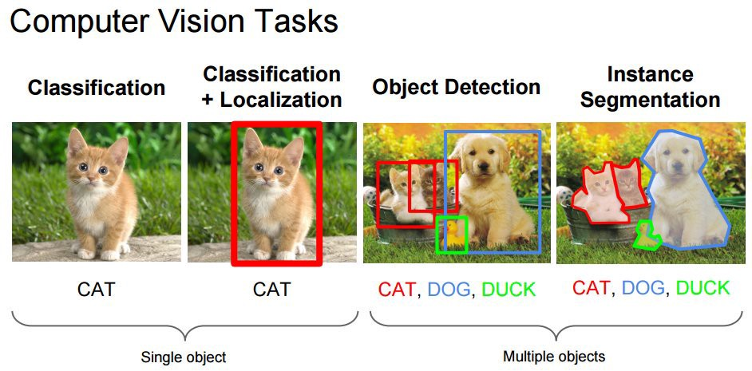

Figure 1: Computer vision task

### OpenCV

OpenCV is the huge open-source library for the computer vision, machine learning, and image processing and now it plays a major role in real-time operation which is very important in today’s systems. By using it, one can process images and videos to identify objects, faces, or even handwriting of a human. When it integrated with various libraries, such as Numpuy, python is capable of processing the OpenCV array structure for analysis. To identify image pattern and its various features we use vector space and perform mathematical operations on these features.

The first OpenCV version was 1.0. OpenCV is released under a BSD license and hence it’s free for both academic and commercial use. It has C++, C, Python and Java interfaces and supports Windows, Linux, Mac OS, iOS and Android. When OpenCV was designed the main focus was real-time applications for computational efficiency. All things are written in optimized C/C++ to take advantage of multi-core processing.

**Applications of OpenCV**: There are lots of applications which are solved using OpenCV, some of them are listed below:-

* Face recognition/ Object recognition
* Automated inspection and surveillance
* Number of people – count (foot traffic in a mall, etc.)
* Vehicle counting on highways along with their speeds
* Anatomoly (defect) detection in the manufacturing process (the odd defective products)
* Street view image stitching
* Video/image search and retrieval
* Robot and driver-less car navigation and control
* Medical image analysis
* Movies – 3d structure from motion

**OpenCV Library Modules**

Following are the main library modules of the OpenCV library.

**1. Core Functionality**

This module covers the basic data structures such as Scalar, Point, Range, etc., that are used to build OpenCV applications. In addition to these, it also includes the multidimensional array Mat, which is used to store the images.

**2. Image Processing**

This module covers various image processing operations such as image filtering, geometrical image transformations, color space conversion, histograms, etc.

**3. Video**

This module covers the video analysis concepts such as motion estimation, background subtraction, and object tracking.

**4. Video I/O**

This module explains the video capturing and video codecs using OpenCV library.

**5. calib3d**

This module includes algorithms regarding basic multiple-view geometry algorithms, single and stereo camera calibration, object pose estimation, stereo correspondence and elements of 3D reconstruction.

**6. Features2d**

This module includes the concepts of feature detection and description

**7. Objdetect**

This module includes the detection of objects and instances of the predefined classes such as faces, eyes, mugs, people, cars, etc.

**8. Highgui**

This is an easy-to-use interface with simple UI capabilities

### Deep Learning:-

Deep learning is an artificial intelligence function that imitates the workings of the human brain in processing data and creating patterns for use in decision making. Deep learning is a subset of machine learning in artificial intelligence (AI) that has networks capable of learning unsupervised from data that is unstructured or unlabelled. Also known as deep neural learning or deep neural network.

Deep learning has evolved hand-in-hand with the digital era, which has brought about an explosion of data in all forms and from every region of the world. This data, known simply as big data, is drawn from sources like social media, internet search engines, e-commerce platforms, and online cinemas, among others. This enormous amount of data is readily accessible and can be shared through fintech applications like cloud computing.

However, the data, which normally is unstructured, is so vast that it could take decades for humans to comprehend it and extract relevant information. Companies realize the incredible potential that can result from unravelling this wealth of information and are increasingly adapting to AI systems for automated support.

A deep learning model is designed to continually analyse data with a logic structure similar to how a human would draw conclusions. To achieve this, deep learning applications use a layered structure of algorithms called an artificial neural network. The design of an artificial neural network is inspired by the biological neural network of the human brain, leading to a process of learning that’s far more capable than that of standard machine learning models.

It’s a tricky prospect to ensure that a deep learning model doesn’t draw incorrect conclusions—like other examples of AI, it requires lots of training to get the learning processes correct. But when it works as it’s intended to, functional deep learning is often received as a scientific marvel that many consider being the backbone of true artificial intelligence.

A great example of deep learning is [Google’s AlphaGo](https://deepmind.com/research/alphago/). Google created a computer program with its own neural network that learned to play the abstract board game called Go, which is known for requiring sharp intellect and intuition. By playing against professional Go players, AlphaGo’s deep learning model learned how to play at a level never seen before in artificial intelligence, and did without being told when it should make a specific move (as a standard machine learning model would require). It caused quite a stir when AlphaGo defeated multiple world-renowned “masters” of the game—not only could a machine grasp the complex techniques and abstract aspects of the game, it was becoming one of the greatest players of it as well.

Figure 2: Difference between ML and DL

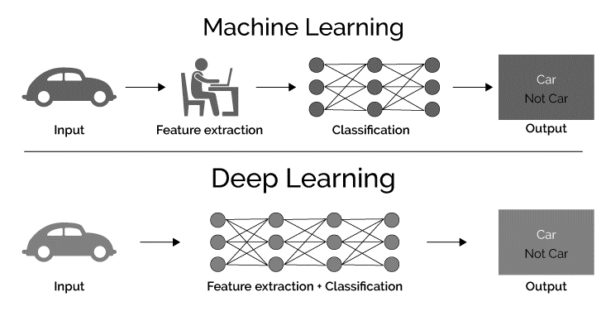

To recap the differences between the two:

* Machine learning uses algorithms to parse data, learn from that data, and make informed decisions based on what it has learned.
* Deep learning structures algorithms in layers to create an "artificial neural network” that can learn and make intelligent decisions on its own.

### Convolutional Neural Network

Convolutional Neural Networks are a type of Deep Learning Algorithm that take the image as an input and learn the various features of the image through filters. This allows them to learn the important objects present in the image, allowing them to discern one image from the other. For example, the convolutional network will learn the specific features of cats that differentiate from the dogs so that when we provide input of cats and dogs, it can easily differentiate between the two.

One important feature of Convolutional Neural Network that sets it apart from other Machine Learning algorithms is its ability to pre-process the data by itself. Thus, you may not spend a lot of resources in data pre-processing. During cold-start, the filters may require hand engineering but with progress in training, they are able to adapt to the learned features and develop filters of their own. Therefore, CNN is continuously evolving with growth in the data.

Fully Connected layers

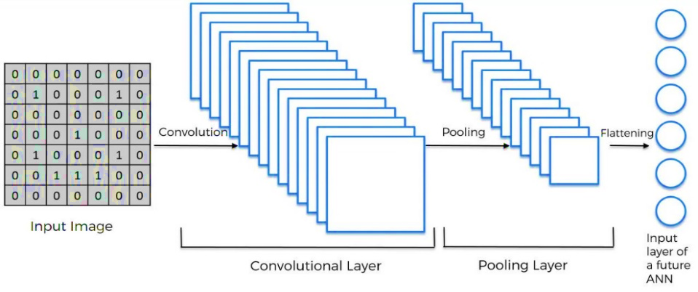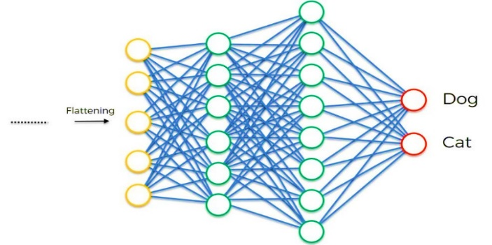

Output

Figure 3: Complete CNN architecture

CNN image classifications takes an input image, process it and classify it under certain categories (Eg. Male, Female). Computers sees an input image as array of pixels and it depends on the image resolution. Based on the image resolution, it will see h x w x d (h = Height, w = Width, d = Dimension). Eg, An image of 6 x 6 x 3 array of matrix of RGB (3 refers to RGB values) and an image of 4 x 4 x 1 array of matrix of grayscale image.

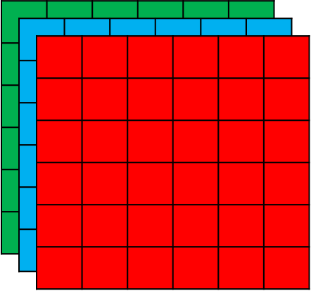

Figure 4(a): Array of rgb matrix (b): Array of grayscale matrix

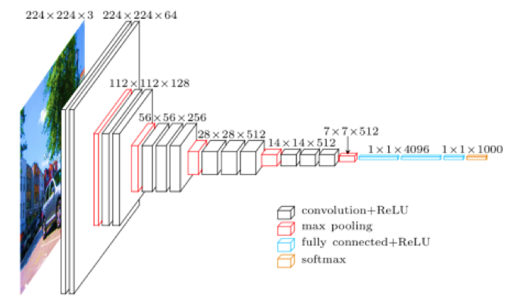Technically, deep learning CNN models to train and test, each input image will pass it through a series of convolution layers with filters (Kernals), Pooling, fully connected layers (FC) and apply Softmax function to classify an object with probabilistic values between 0 and 1.

Figure 5: Basic idea of image processing using cnn.

#### Convolution Layer

Convolution is the first layer to extract features from an input image. Convolution preserves the relationship between pixels by learning image features using small squares of input data. It is a mathematical operation that takes two inputs such as image matrix and a filter or kernel.

Figure 6: Input image and feature detector

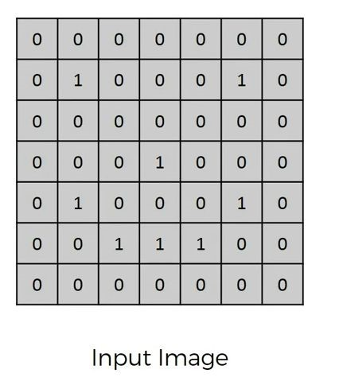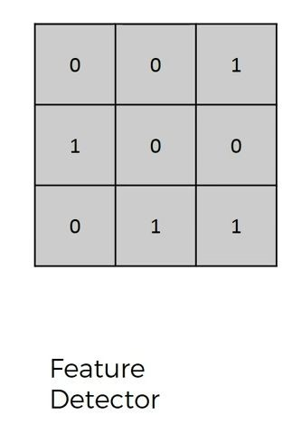

Consider a 7 x 7 whose image pixel values are 0, 1 and filter matrix 3 x 3 as shown in above. Then the convolution of 7 x 7 image matrix multiplies with 3 x 3 filter matrix which is called **“Feature Map”** as output shown in below.

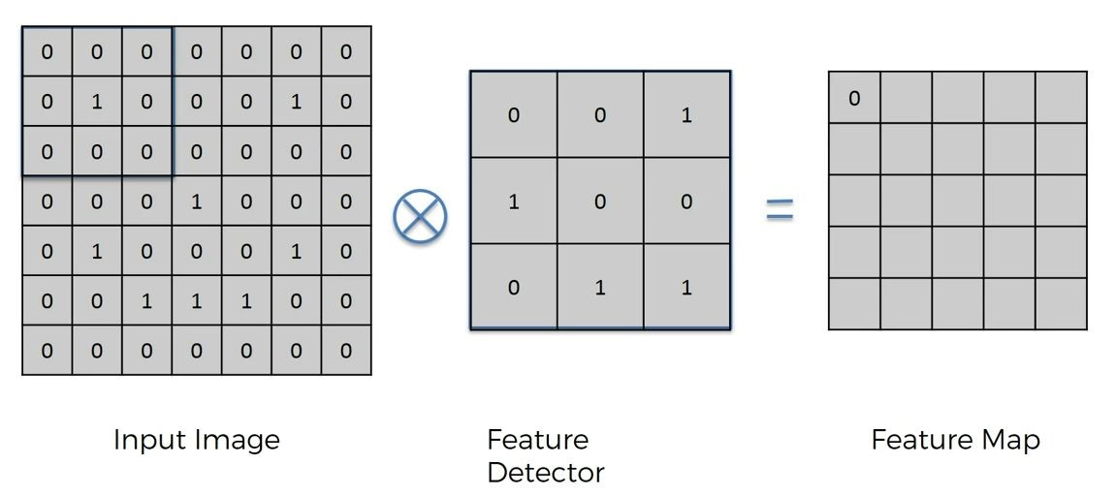

Figure 4 (a): Image matrix multiplies kernel or filter matrix

1. 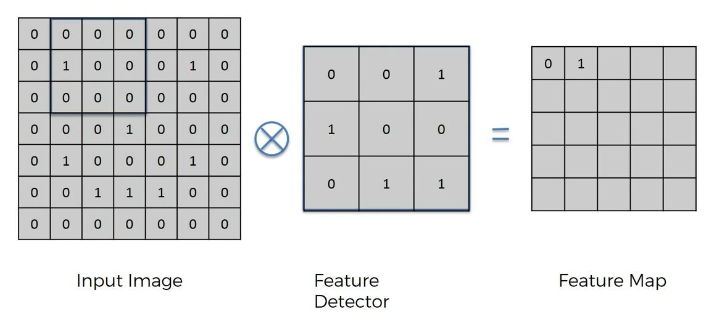
2. 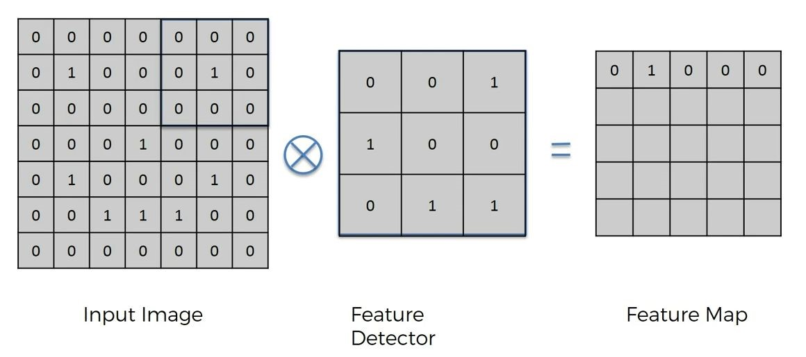
3. 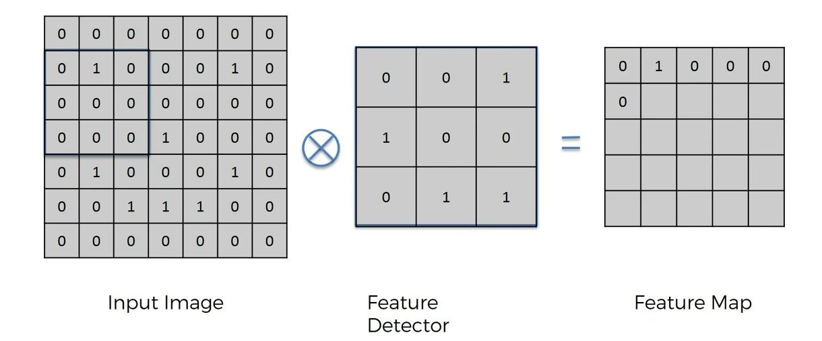
4. 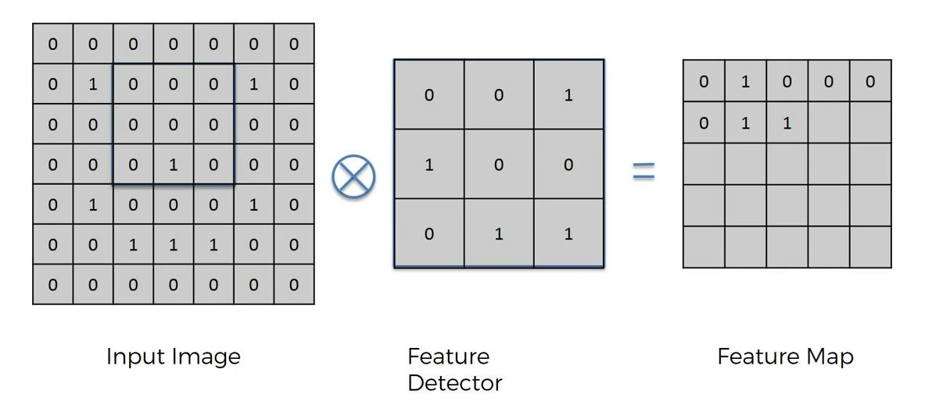
5. 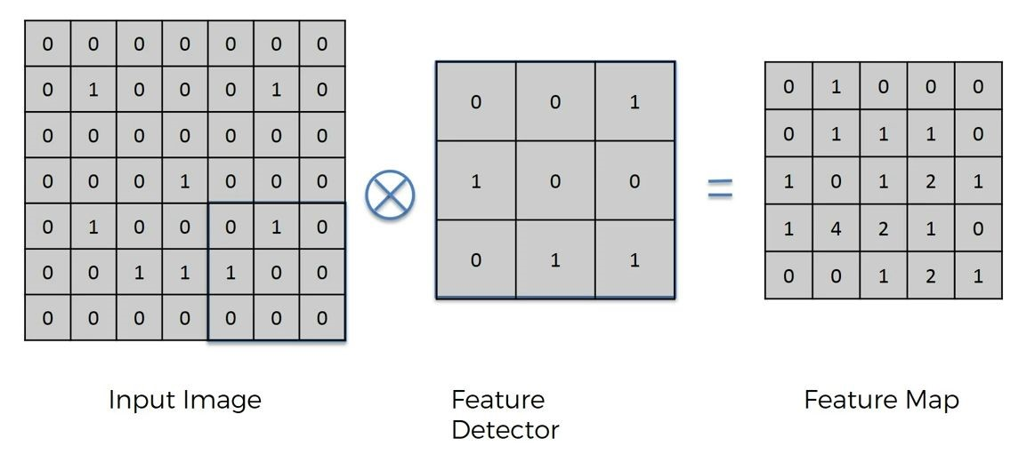

Figure 7 (f): Output Matrix

Convolution of an image with different filters can perform operations such as edge detection, blur and sharpen by applying filters. The below example shows various convolution image after applying different types of filters (Kernels).

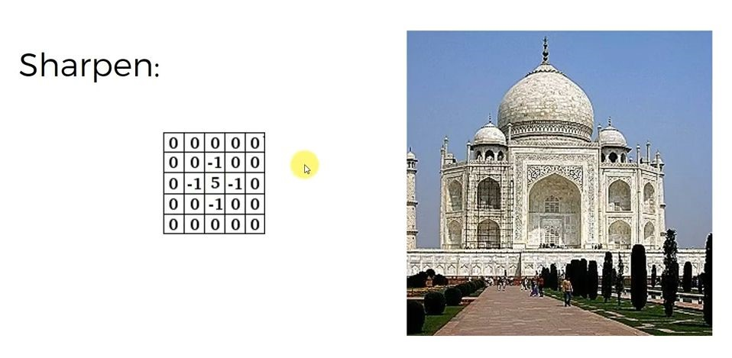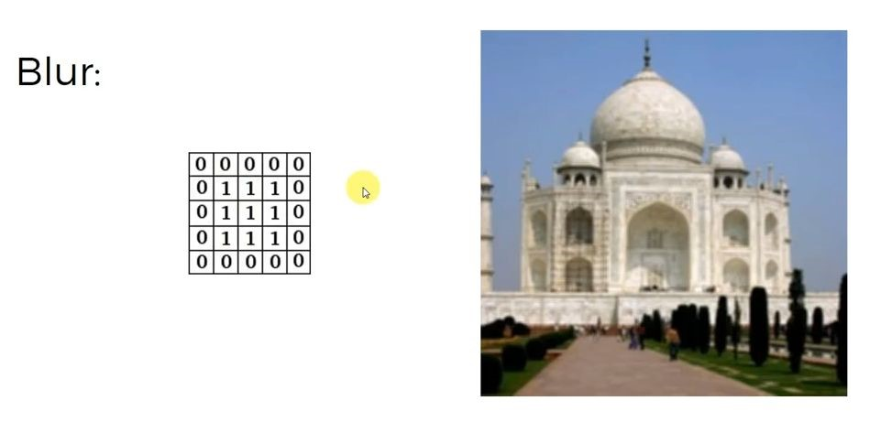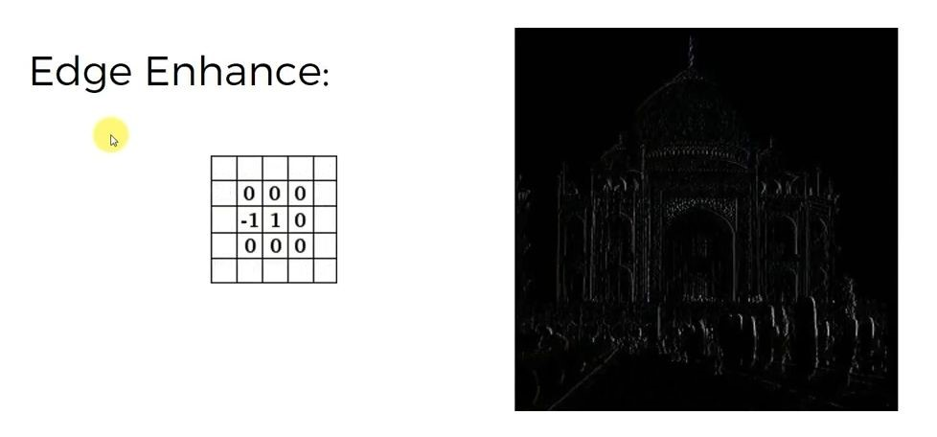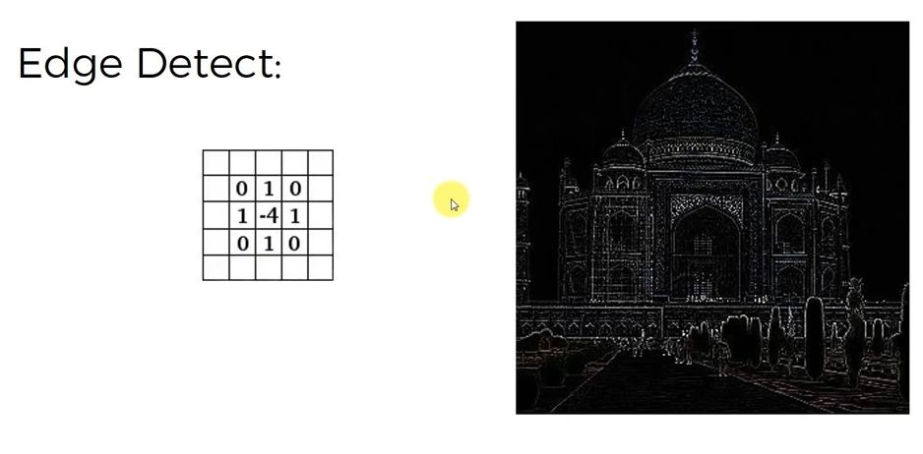

Figure 8: Some common filters

#### Relu Layer

ReLU stands for Rectified Linear Unit for a non-linear operation. The output is

**ƒ(x) = max (0, x).**

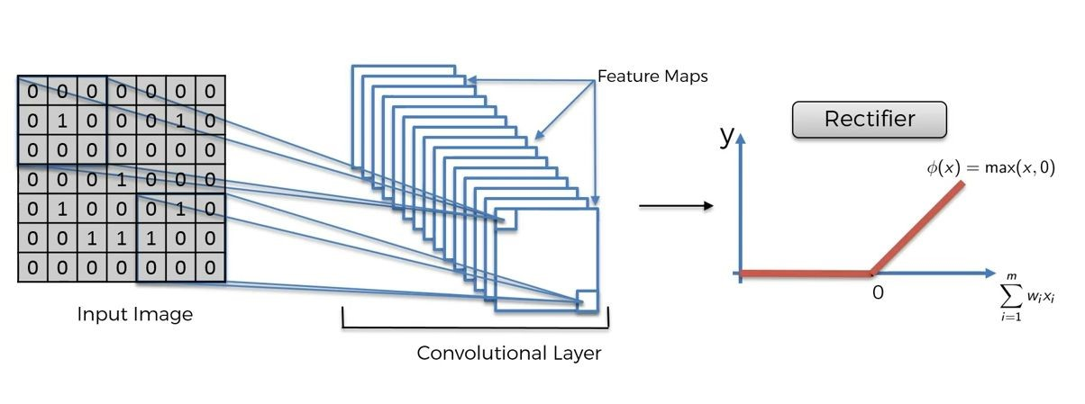

Figure 9: ReLU operation

ReLU’s purpose is to introduce non-linearity in our Convolution Layer. Since, the real world data would want our Convolution Layer to learn would be non-negative linear values. Most of the data scientists use ReLU since performance wise ReLU is better than the other two.

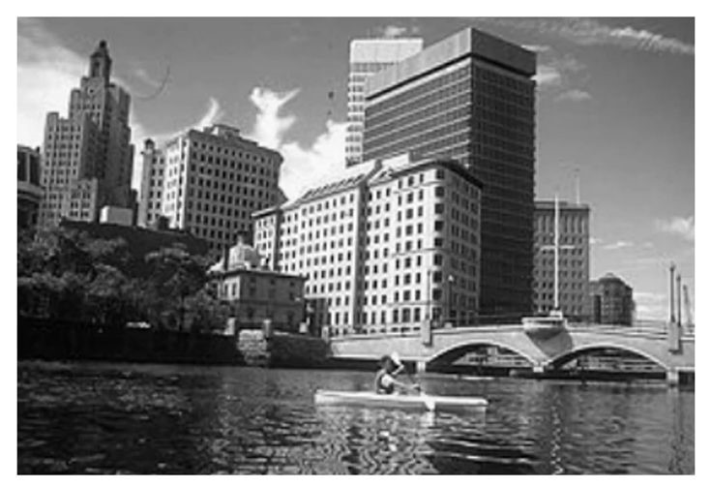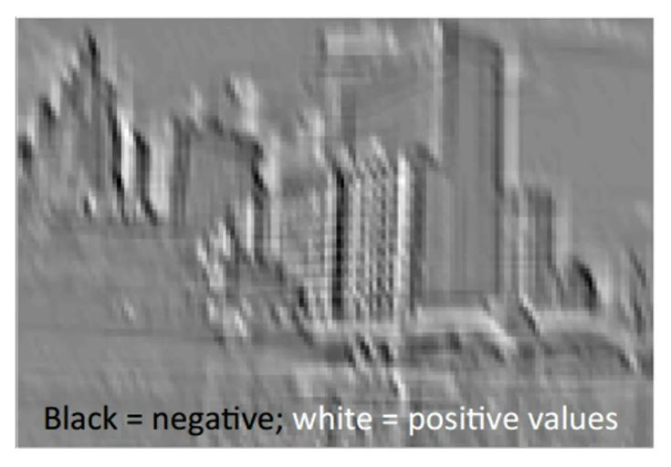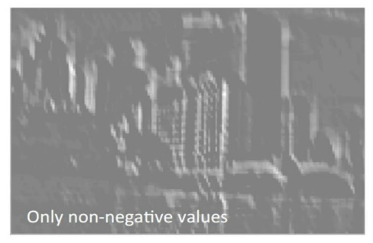

Figure 10 (a): Normal Image (b): Convolution layer output (c): ReLU layer output

#### Max ****Pooling****

Pooling layers section would reduce the number of parameters when the images are too large. Max pooling takes the largest element from the rectified feature map. Taking the largest element could also take the average pooling. Sum of all elements in the feature map call as sum pooling.

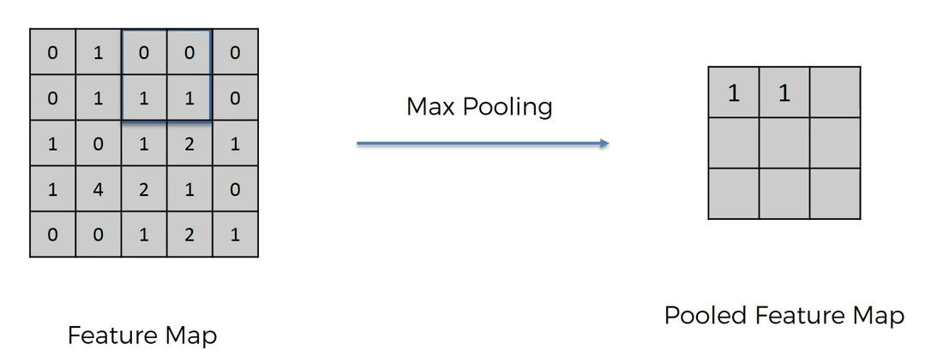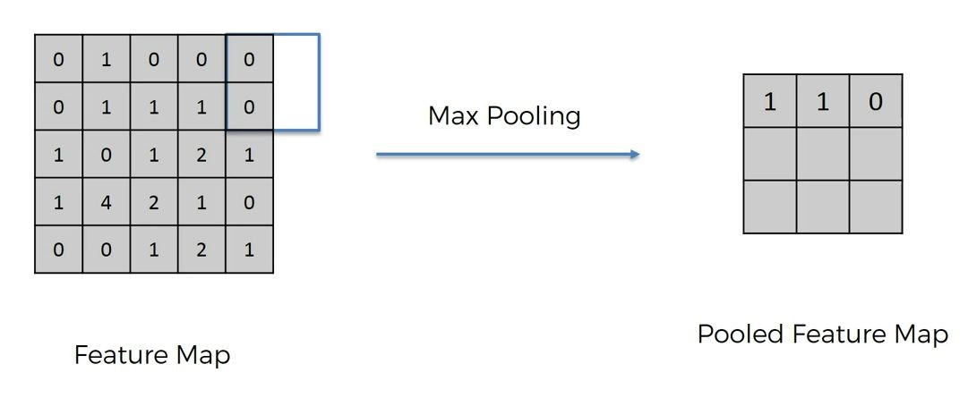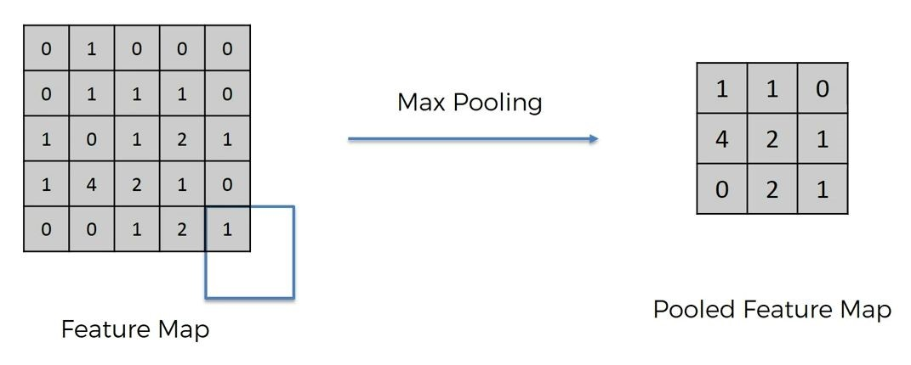

Figure 11: Max pooling output matrix

#### Flattening

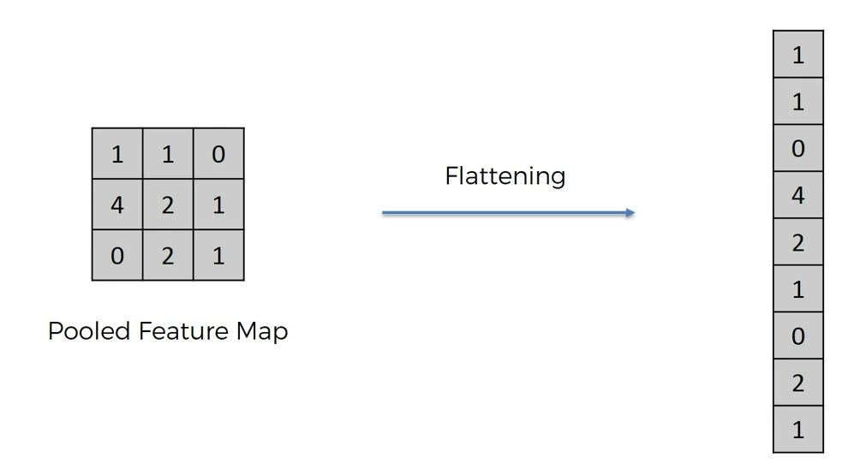Flattening is converting the data into a 1-dimensional array for inputting it to the next layer. The last stage of a convolutional neural network (CNN) is a classifier. It is called a dense layer, which is just an artificial neural network (ANN) classifier. And an ANN classifier needs individual features, just like any other classifier. This means it needs a feature vector. Therefore, you need to convert the output of the convolutional part of the CNN into a 1D feature vector, to be used by the ANN part of it. This operation is called flattening. It gets the output of the convolutional layers, flattens all its structure to create a single long feature vector to be used by the dense layer for the final classification.

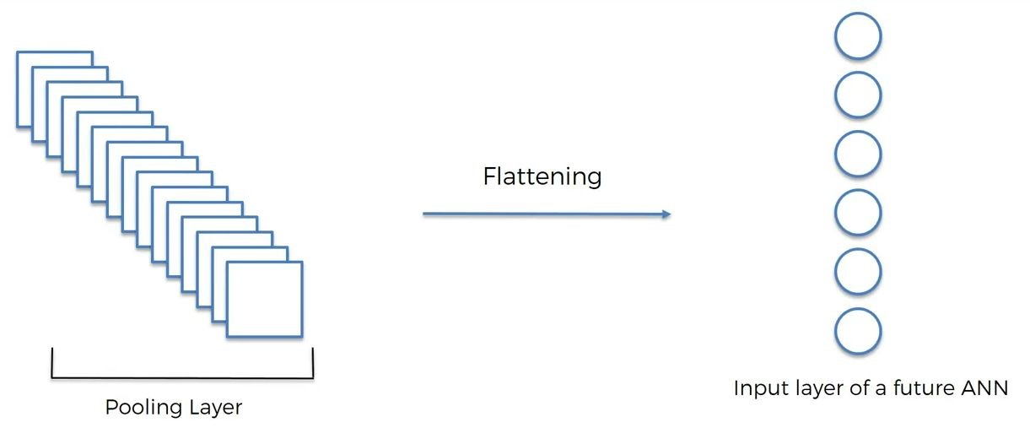

Adding multiple convolutional layers and pooling layers, the image will be processed for feature extraction. As the layers go deeper and deeper, the features that the model deals with become more complex. For example, at the early stage of Conv.layer, it looks up for oriented line patterns and then finds some simple figures. At the deep stage, it can catch the specific forms of objects and finally able to detect the object of an input image.

This is an artificial neural network in cnn. An **input layer**which is the data we provide to the ANN**.**We have the **hidden layers**, which is where the magic happens. Lastly, we have the **output layer**, which is where the finished computations of the network are placed for us to use.

#### Fully Connected Layer

The layer we call as FC layer, we flattened our matrix into vector and feed it into a fully connected layer like a neural network. In our ANNs we have these units of calculation called neurons.

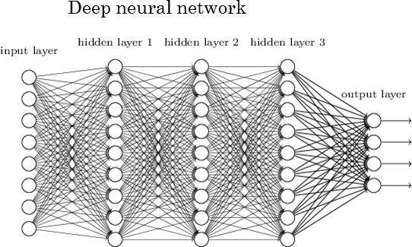These artificial neurons are connected by synapses which are really just weighted values. What this means is that given a number, a neuron will perform some sort of calculation and then the result of this calculation will be multiplied by a weight as it “travels.”

Figure 12: Fully Connected Layer

+ Relu

## Front End

### HTML 5

HTML5 is the next major revision of the HTML standard superseding HTML 4.01, XHTML 1.0, and XHTML 1.1. HTML5 is a standard for structuring and presenting content on the World Wide Web.HTML5 is a cooperation between the World Wide Web Consortium (W3C) and the Web Hypertext Application Technology Working Group (WHATWG).The new standard incorporates features like video playback and drag-and-drop that have been previously dependent on third-party browser plug-ins such as Adobe Flash, Microsoft Silverlight, and Google Gears.

**Browser Support**

The latest versions of Apple Safari, Google Chrome, Mozilla Firefox, and Opera all support many HTML5 features and Internet Explorer 9.0 will also have support for some HTML5 functionality. The mobile web browsers that come pre-installed on iPhones, iPads, and Android phones all have excellent support for HTML5.HTML5 supports both audio and video whereas none of these was a part of HTML. HTML does not allow JavaScript to run within the web browser whereas HTML5 provides full support for JavaScript to run in the background. HTML5 supports new kinds of form controls, for example: dates and times, email, number, range, tel, URL, search etc. There are many new elements introduced in HTML5. Some of the most important ones are: summary, time, audio, details, embed, figcaption, figure, footer, header, article, canvas, nav, output, section, source, track, video, etc.

### Bootstrap:-

Bootstrap is a free and open-source CSS framework directed at responsive, mobile-first front-end web development. It contains CSS- and JavaScript-based design templates for typography, forms, buttons, navigation, and other interface components. Bootstrap 4 is the newest version of Bootstrap, which is the most popular HTML, CSS, and JavaScript framework for developing responsive, mobile-first websites. Bootstrap 4 is completely free to download and use.

Bootstrap is CSS based framework developed by twitter for creating responsive web application. It provide multiple ways of implementation:-

**Installation**: Install Bootstrap’s source Sass and JavaScript files via npm, Composer, or Meteor.

**Bootstrap Themes:** Themes are built on Bootstrap as their own extended frameworks, rich with new components and plugins, documentation, and powerful build tools.

**Bootstrap Icons:**For the first time ever, Bootstrap has its own open source SVG icon library, designed to work best with our components and documentation. Bootstrap Icons are designed to work best with Bootstrap components, but they’ll work in any project. They’re SVGs, so they scale quickly and easily, can be implemented in several ways, and can be styled with CSS.

**BootstrapCDN**: It is used to build a quick responsive website provided for free by the folks at Stack Path. BootstrapCDN is a public content delivery network. Users of BootstrapCDN can load CSS, JavaScript and images remotely, from its servers using the following links.

**<-- Bootstrap CSS -->**

<link rel="stylesheet" href="https://maxcdn.bootstrapcdn.com/bootstrap/4.0.0/css/bootstrap.min.css" integrity="sha384-Gn5384xqQ1aoWXA+058RXPxPg6fy4IWvTNh0E263XmFcJlSAwiGgFAW/dAiS6JXm" crossorigin="anonymous">

**<!--JavaScript -->**

**<!—jQuery --- >**

<script src="https://code.jquery.com/jquery-3.2.1.slim.min.js" integrity="sha384-KJ3o2DKtIkvYIK3UENzmM7KCkRr/rE9/Qpg6aAZGJwFDMVNA/GpGFF93hXpG5KkN" crossorigin="anonymous"></script>

**< ---- Popper.js --- >**

<script src="https://cdnjs.cloudflare.com/ajax/libs/popper.js/1.12.9/umd/popper.min.js" integrity="sha384-ApNbgh9B+Y1QKtv3Rn7W3mgPxhU9K/ScQsAP7hUibX39j7fakFPskvXusvfa0b4Q" crossorigin="anonymous"></script>

**<--- Bootstrap JS --- >**

<script src="https://maxcdn.bootstrapcdn.com/bootstrap/4.0.0/js/bootstrap.min.js" integrity="sha384-JZR6Spejh4U02d8jOt6vLEHfe/JQGiRRSQQxSfFWpi1MquVdAyjUar5+76PVCmYl" crossorigin="anonymous"></script>

Bootstrap is built to work best in the latest desktop and mobile browsers, meaning older browsers might display differently styled, though fully functional, renderings of certain components.

**Supported browsers**

Specifically, we support the latest versions of the following browsers and platforms.

Alternative browsers which use the latest version of WebKit, Blink, or Gecko, whether directly or via the platform's web view API, are not explicitly supported. However, Bootstrap should (in most cases) display and function correctly in these browsers as well. More specific support information is provided below.

**Mobile devices**

Generally speaking, Bootstrap supports the latest versions of each major platform's default browsers. Note that proxy browsers (such as Opera Mini, Opera Mobile's Turbo mode, UC Browser Mini, Amazon Silk) are not supported.

|  |  |  |  |
| --- | --- | --- | --- |
|  | Chrome | Firefox | Safari |
| Android | Supported | Supported | N/A |
| iOS | Supported | Supported | Supported |

**Desktop browsers**

Similarly, the latest versions of most desktop browsers are supported.

|  |  |  |  |  |  |
| --- | --- | --- | --- | --- | --- |
|  | Chrome | Firefox | Internet Explorer | Opera | Safari |
| Mac | Supported | Supported | N/A | Supported | Supported |
| Windows | Supported | Supported | Supported | Supported | Not supported |

On Windows, we support Internet Explorer 8-11.

For Firefox, in addition to the latest normal stable release, we also support the latest Extended Support Release (ESR) version of Firefox.

Unofficially, Bootstrap should look and behave well enough in Chromium and Chrome for Linux, Firefox for Linux, and Internet Explorer 7, as well as Microsoft Edge, though they are not officially supported.

## Back End

### **Python**:-

**Python** is a general-purpose interpreted, interactive, object-oriented, and high-level programming language. It was created by Guido van Rossum during 1985- 1990. Like Perl, Python source code is also available under the GNU General Public License (GPL). Python is a high-level, interpreted, interactive and object-oriented scripting language. Python is designed to be highly readable. It uses English keywords frequently where as other languages use punctuation, and it has fewer syntactical constructions than other languages.

**Python** is a MUST for students and working professionals to become a great Software Engineer specially when they are working in Web Development Domain. Key advantages of learning Python:

* **Python is Interpreted** − Python is processed at runtime by the interpreter. You do not need to compile your program before executing it. This is similar to PERL and PHP.
* **Python is Interactive** − You can actually sit at a Python prompt and interact with the interpreter directly to write your programs.
* **Python is Object-Oriented** − Python supports Object-Oriented style or technique of programming that encapsulates code within objects.
* **Python is a Beginner's Language** − Python is a great language for the beginner-level programmers and supports the development of a wide range of applications from simple text processing to WWW browsers to games.

**Characteristics of Python**

Following are important characteristics of Python Programming −

* It supports functional and structured programming methods as well as OOP.
* It can be used as a scripting language or can be compiled to byte-code for building large applications.
* It provides very high-level dynamic data types and supports dynamic type checking.
* It supports automatic garbage collection.
* It can be easily integrated with C, C++, COM, ActiveX, CORBA, and Java.

**Applications of Python**

* **Easy-to-learn** − Python has few keywords, simple structure, and a clearly defined syntax. This allows the student to pick up the language quickly.
* **Easy-to-read** − Python code is more clearly defined and visible to the eyes.
* **Easy-to-maintain** − Python's source code is fairly easy-to-maintain.
* **A broad standard library** − Python's bulk of the library is very portable and cross-platform compatible on UNIX, Windows, and Macintosh.
* **Interactive Mode** − Python has support for an interactive mode which allows interactive testing and debugging of snippets of code.
* **Portable** − Python can run on a wide variety of hardware platforms and has the same interface on all platforms.
* **Extendable** − You can add low-level modules to the Python interpreter. These modules enable programmers to add to or customize their tools to be more efficient.
* **Databases** − Python provides interfaces to all major commercial databases.
* **GUI Programming** − Python supports GUI applications that can be created and ported to many system calls, libraries and windows systems, such as Windows MFC, Macintosh, and the X Window system of Unix.

## Libraries Used

### **Tensor Flow**

TensorFlow is an open source software library for numerical computation using data-flow graphs. It was originally developed by the Google Brain Team within Google's Machine Intelligence research organization for machine learning and deep neural networks research, but the system is general enough to be applicable in a wide variety of other domains as well. It reached version 1.0 in February 2017, and has continued rapid development, with 21,000+ commits thus far, many from outside contributors. This article introduces TensorFlow, its open source community and ecosystem, and highlights some interesting TensorFlow open sourced models.

**History:** A couple of years ago, deep learning started to outperform all other machine learning algorithms when giving a massive amount of data. Google saw it could use these deep neural networks to improve its services: Gmail, Photo, Google search engine. They build a framework called **Tensorflow** to let researchers and developers work together on an AI model. Once developed and scaled, it allows lots of people to use it.

It was first made public in late 2015, while the first stable version appeared in 2017. It is open source under Apache Open Source license. You can use it, modify it and redistribute the modified version for a fee without paying anything to Google.

**TensorFlow Architecture**

Tensorflow architecture works in three parts:

* Pre-processing the data
* Build the model
* Train and estimate the model

It is called Tensorflow because it takes input as a multi-dimensional array, also known as **tensors**. You can construct a sort of **flowchart** of operations (called a Graph) that you want to perform on that input. The input goes in at one end, and then it flows through this system of multiple operations and comes out the other end as output. This is why it is called TensorFlow because the tensor goes in it flows through a list of operations, and then it comes out the other side.

TensorFlow hardware, and software requirements can be classified into

**Development Phase**: This is when you train the mode. Training is usually done on your Desktop or laptop.

**Run Phase or Inference Phase**: Once training is done Tensorflow can be run on many different platforms. You can run it on

* Desktop running Windows, macOS or Linux
* Cloud as a web service
* Mobile devices like iOS and Android

You can train it on multiple machines then you can run it on a different machine, once you have the trained model. The model can be trained and used on GPUs as well as CPUs. GPUs were initially designed for video games. In late 2010, Stanford researchers found that GPU was also very good at matrix operations and algebra so that it makes them very fast for doing these kinds of calculations. Deep learning relies on a lot of matrix multiplication. TensorFlow is very fast at computing the matrix multiplication because it is written in C++. Although it is implemented in C++, TensorFlow can be accessed and controlled by other languages mainly, Python.

TensorFlow is the best library of all because it is built to be accessible for everyone. Tensorflow library incorporates different API to build at scale deep learning architecture like CNN or RNN. TensorFlow is based on graph computation; it allows the developer to visualize the construction of the neural network with Tensorboad. This tool is helpful to debug the program. Finally, Tensorflow is built to be deployed at scale. It runs on CPU and GPU.

Tensorflow attracts the largest popularity on GitHub compare to the other deep learning framework.

### Keras

**KERAS** is an Open Source Neural Network library written in Python that runs on top of Theano or Tensorflow. It is designed to be modular, fast and easy to use. It was developed by François Chollet, a Google engineer.

Keras doesn't handle low-level computation. Instead, it uses another library to do it, called the "Backend. So Keras is high-level API wrapper for the low-level API, capable of running on top of TensorFlow, CNTK, or Theano.

Keras High-Level API handles the way we make models, defining layers, or set up multiple input-output models. In this level, Keras also compiles our model with loss and optimizer functions, training process with fit function. Keras doesn't handle Low-Level API such as making the computational graph, making tensors or other variables because it has been handled by the "backend" engine.

### **Numpy**

NumPy is a python package, primarily used for scientific and numerical computing. NumPy is a portmanteau of two words, coined by the blending of “Numerical” and “Python”. It is very famous among data scientists and analysts for its efficiency (run time speed) and a wide range of array operations, it provides. In this post, we will be getting acquainted with the NumPy library. NumPy was originally developed as “numeric” by Jim Hugunin in the late 90s. The present version of numpy was created by Travis Oliphant in 2005 by incorporating features from competing for numarray into numeric.

**NumPy Library**

NumPy library lets us store and work on a large amount of dense data effectively and efficiently. In NumPY data is stored in the form of arrays. These arrays are the crux of this library. Arrays in NumPy are similar to python built-in type “list”. The closest approximate to a numpy array is a C array. This can be attributed to the fact that NumPy is written primarily in C language. But numpy arrays provide more efficient data storage and operations compared to both.

**Characteristics**

* Support n-dimensional arrays: NumPy arrays are multidimensional or n-dimensional lists or matrices of fixed size with homogeneous elements ( i.e. data type of all the elements in the array is the same).
* Require a contiguous allocation of memory: This improves the efficiency as all elements of the array become directly accessible at a fixed offset from the starting of the array.
* Support selection using crop, slice, choose, etc.
* Support vectorised and complex operations.
* Support linear algebra, Fourier transform, and sophisticated broadcasting functions.
* In nutshell, NumPy provides capabilities similar to C/C++ but the simplicity of the use of Python.

**Advantages of NumPy**

* The core of Numpy is its arrays. One of the main advantages of using Numpy arrays is that they take less memory space and provide better runtime speed when compared with similar data structures in python (lists and tuples).
* Numpy support some specific scientific functions such as linear algebra. They help us in solving linear equations.
* Numpy support vectorised operations, like elementwise addition and multiplication, computing Kronecker product, etc. Python lists fail to support these features.
* It is a very good substitute for MATLAB, OCTAVE, etc as it provides similar functionalities and supports with faster development and less mental overhead(as python is easy to write and comprehend)
* NumPy is very good for data analysis.

**Disadvantages of NumPy**

* Using “nan” in Numpy: “Nan” stands for “not a number”. It was designed to address the problem of missing values. NumPy itself supports “nan” but lack of cross-platform support within Python makes it difficult for the user. That’s why we may face problems when comparing values within the Python interpreter.
* Require a contiguous allocation of memory: Insertion and deletion operations become costly as data is stored in contiguous memory locations as shifting it requires shifting.

### Pandas

Pandas is an open-source Python Library providing high-performance data manipulation and analysis tool using its powerful data structures. The name Pandas is derived from the word Panel Data – an Econometrics from Multidimensional data.

In 2008, developer Wes McKinney started developing pandas when in need of high performance, flexible tool for analysis of data.

Prior to Pandas, Python was majorly used for data munging and preparation. It had very little contribution towards data analysis. Pandas solved this problem. Using Pandas, we can accomplish five typical steps in the processing and analysis of data, regardless of the origin of data — load, prepare, manipulate, model, and analyze. Python with Pandas is used in a wide range of fields including academic and commercial domains including finance, economics, Statistics, analytics, etc.

**Key Features of Pandas**

* Fast and efficient DataFrame object with default and customized indexing.
* Tools for loading data into in-memory data objects from different file formats.
* Data alignment and integrated handling of missing data.
* Reshaping and pivoting of date sets.
* Label-based slicing, indexing and subsetting of large data sets.
* Columns from a data structure can be deleted or inserted.
* Group by data for aggregation and transformations.
* High performance merging and joining of data.
* Time Series functionality.

In short, Pandas is a Software Library in Computer Programming. It is written for the Python Programming Language. They are used in Python to deal with data analysis and manipulation. To put it in simpler words, Pandas help us to organize data and manipulate the data by putting it in a tabular form.

Pandas is built on top of the NumPy package, meaning a lot of the structure of NumPy is used or replicated in Pandas. Data in pandas is often used to feed statistical analysis in SciPy, plotting functions from Matplotlib, and machine learning algorithms in Scikit-learn. Jupyter Notebooks offer a good environment for using pandas to do data exploration and modeling, but pandas can also be used in text editors just as easily.

Jupyter Notebooks give us the ability to execute code in a particular cell as opposed to running the entire file. This saves a lot of time when working with large datasets and complex transformations. Notebooks also provide an easy way to visualize pandas’ DataFrames and plots.

This tool is essentially your data’s home. Through pandas, you get acquainted with your data by cleaning, transforming, and analysing it. For example, say you want to explore a dataset stored in a CSV on your computer. Pandas will extract the data from that CSV into a DataFrame — a table, basically — then let you do things like:

* Calculate statistics and answer questions about the data, like
* What's the average, median, max, or min of each column?
* Does column A correlate with column B?
* What does the distribution of data in column C look like?
* Clean the data by doing things like removing missing values and filtering rows or columns by some criteria
* Visualize the data with help from Matplotlib. Plot bars, lines, histograms, bubbles, and more.
* Store the cleaned, transformed data back into a CSV, other file or database

### Matplotlib

Matplotlib is one of the most popular Python packages used for data visualization. It is a cross-platform library for making 2D plots from data in arrays. Matplotlib is written in Python and makes use of NumPy, the numerical mathematics extension of Python. It provides an object-oriented API that helps in embedding plots in applications using Python GUI toolkits such as PyQt, WxPythonotTkinter. It can be used in Python and IPython shells, Jupyter notebook and web application servers .

Matplotlib was originally written by John D. Hunter in 2003. The current stable version is 2.2.0 released in January 2018.

Figure 13: Types of graph

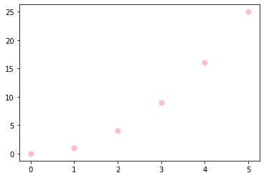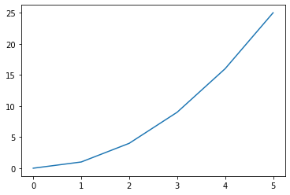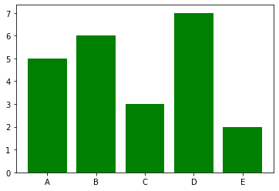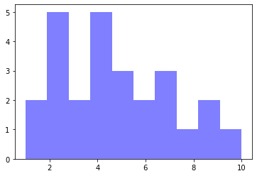

One of the greatest benefits of visualization is that it allows us visual access to huge amounts of data in easily digestible visuals. Matplotlib consists of several plots like line, bar, scatter, histogram etc. It tries to make easy things easy and hard things possible. You can generate plots, histograms, power spectra, bar charts, errorcharts, scatterplots, etc., with just a few lines of code.

## Framework Used

### Django

Django is a high-level Python web framework that enables rapid development of secure and maintainable websites. Built by experienced developers, Django takes care of much of the hassle of web development, so you can focus on writing your app without needing to reinvent the wheel. It is free and open source, has a thriving and active community, great documentation, and many options for free and paid-for support.

**History**

Django was initially developed between 2003 and 2005 by a web team who were responsible for creating and maintaining newspaper websites. After creating a number of sites, the team began to factor out and reuse lots of common code and design patterns. This common code evolved into a generic web development framework, which was open-sourced as the "Django" project in July 2005.

Django has continued to grow and improve, from its first milestone release (1.0) in September 2008 through to the recently-released version 2.0 (2017). Each release has added new functionality and bug fixes, ranging from support for new types of databases, template engines, and caching, through to the addition of "generic" view functions and classes (which reduce the amount of code that developers have to write for a number of programming tasks).

Django helps you write software that is:

**Complete**

Django follows the "Batteries included" philosophy and provides almost everything developers might want to do "out of the box". Because everything you need is part of the one "product", it all works seamlessly together, follows consistent design principles, and has extensive and up-to-date documentation.

**Versatile**

Django can be (and has been) used to build almost any type of website — from content management systems and wikis, through to social networks and news sites. It can work with any client-side framework, and can deliver content in almost any format (including HTML, RSS feeds, JSON, XML, etc). Internally, while it provides choices for almost any functionality you might want (e.g. several popular databases, templating engines, etc.), it can also be extended to use other components if needed.

**Secure**

Django helps developers avoid many common security mistakes by providing a framework that has been engineered to "do the right things" to protect the website automatically. For example, Django provides a secure way to manage user accounts and passwords, avoiding common mistakes like putting session information in cookies where it is vulnerable (instead cookies just contain a key, and the actual data is stored in the database) or directly storing passwords rather than a password hash.  
  
A password hash is a fixed-length value created by sending the password through a cryptographic hash function. Django can check if an entered password is correct by running it through the hash function and comparing the output to the stored hash value. However due to the "one-way" nature of the function, even if a stored hash value is compromised it is hard for an attacker to work out the original password. Django enables protection against many vulnerabilities by default, including SQL injection, cross-site scripting, cross-site request forgery and clickjacking (see Website security for more details of such attacks).

**Scalable**

Django uses a component-based “shared-nothing” architecture (each part of the architecture is independent of the others, and can hence be replaced or changed if needed). Having a clear separation between the different parts means that it can scale for increased traffic by adding hardware at any level: caching servers, database servers, or application servers. Some of the busiest sites have successfully scaled Django to meet their demands (e.g. Instagram and Disqus, to name just two).

**Maintainable**

Django code is written using design principles and patterns that encourage the creation of maintainable and reusable code. In particular, it makes use of the Don't Repeat Yourself (DRY) principle so there is no unnecessary duplication, reducing the amount of code. Django also promotes the grouping of related functionality into reusable "applications" and, at a lower level, groups related code into modules (along the lines of the Model View Controller (MVC) pattern).

**Portable**

Django is written in Python, which runs on many platforms. That means that you are not tied to any particular server platform, and can run your applications on many flavours of Linux, Windows, and Mac OS X. Furthermore, Django is well-supported by many web hosting providers, who often provide specific infrastructure and documentation for hosting Django sites.

# LITERATURE REVIEW

Face recognition and the classification of the age and gender of face objects are two interesting field of research in this area. In this paper we provide a brief review of some of existing methods in face, gender and age recognition.

In Dobry et al.(2009), anchor modeling utilizes a back end SVM to model the distribution of similarity scores between training data and all the anchor speaker models. Due to the different aspects of modeling, combining different classification methods together can often significantly improve the overall performance (M¨uller and Burkhardt, 2007; van Heerden et al., 2010; Meinedo and Trancoso,2010; Bocklet et al., 2010; Kockmann et al., 2010; Lingenfelser et al., 2010).Humans perceive gender not only based on the face, but also on the surrounding context such as hair, clothing and skin tone [15, 6], gait [14] and the whole body [6, 1]. Below, we review relevant work on gender prediction from facial images only. Theproblem of gender classification based on human faces has been extensively studied in the literature [20, 3].There are two popular methods. The first one is proposed by Moghaddam et al. [20] where a Support Vector Machine (SVM) is utilized for gender classification based on thumbnail face images. The second was presented by Baluja et al.[3] who applied the Adaboost algorithm for gender prediction. Recently, due to the popularity of Local Binary Patterns (LBP) in face recognition applications [2], Yang et al.[30] used LBP histogram features for gender feature representation, and the Adaboost algorithm to learn the best local features for classification. Experiments were performed to predict age, gender and ethnicity from face images. . Other local descriptors have also been adopted for gender classification. Wang et al. [27] proposed a novel gender recognition method using Scale Invariant Feature Transform (SIFT) descriptors and shape contexts. Once again, Adaboost was used to select features from face images and form a strong classifier. Gao et al. performed face-based gender classification on consumer images acquired from a multi-ethnic face database. To overcome the non-uniformity of pose, expression, and illumination changes, they proposed the usage of Active Shape Models (ASM) to normalize facial texture. The work concluded that the consideration of ethnic factors can help improve gender classification accuracy in a multi-ethnic environment.

2.1. Age Recognition

Not only the present studies, in the 90s used the analysis of facial geometry to estimate the age of a person, but also more recent techniques like the pipeline used in, presenting a combination of Biologically Inspired Features (BIF) and then using Canonical Correlation Analysis (CCA) and Partial Least Square (PLS) based methods. Indeed BIF were already used in to represent face images, paving the way to works like, showing that the automatic approach had matched the human performance. In fact, most of the approaches previous to CNNs were based on a two-stage pipeline, i.e. extracting features such as Local Binary Patterns (LBP), and then classifying with a Support Vector Machine (SVM), or a Multi-layer

Perceptron (MLP). On the contrary, CNN based methods typically implements the two-step pipeline described above in just one step: the network learns both extracting the best features and either classifying such features into age categories or performing age regression.

Deeper CNN models have been also applied to age and gender recognition, although most of them depend on domain-specific pre-training .Cascaded combinations of deep models were also considered. CNNs for facial images analysis have not been restricted to age estimation, but also to face verification, facial attribute estimation, and gender recognition. One illustrative example is the method which achieves a 99.2% face verification accuracy on the challenging Labelled Faces in the Wild dataset. Unfortunately, this so impressive performance has not been yet achieved in other facial analysis tasks like gender recognition, for example, as shown next.

2.2. Gender Recognition

Regarding gender recognition, in contrast to age analysis, there is work from the early 90s where neural networks were already proposed, like the pioneering approach presented. Authors proposed two neural network structures, an auto encoder and a classier whose input was the encoded output layer of the auto encoder. The drawback of this method was that it relied on manual cropping, scaling and rotating the face of the picture, which was taken in a controlled environment.

Inspired from the age estimation methodology, pipelines based on a feature extractor and a stacked classier were also proposed. On the other hand, the same CNN-based methods used for age were also applied to gender demonstrating that CNNs are truly capable of learning how to perform different tasks without any modification besides the data used for learning. CNN is trained to perform gender recognition by _ne-tuning a pre-trained network, and then an SVM is trained using the deep features computed by the CNN.

|  |  |  |  |  |
| --- | --- | --- | --- | --- |
| **Sno** | **Title of paper** | **Author** | **Publication** | **Technique Used** |
|  | Age and Gender Estimation of Unfiltered Faces | Eran Eidinger, Roee | IEEE TRANSACTIONDEC. 2014 | Robust face alignment technique, SVM |
|  | Automated Estimation of Human Age, Gender and Expression | Yaoyu Tao | Stanford, CA 94305, USA taoyaoyu@stanford.edu | LBP & Gabor filter LDA algorithm |
|  | Comparison of Recent Machine Learning Techniques for Gender Recognition from Facial Images | Joseph Lemley Sami Abdul-Wahid Dipayan Banik | Central Washington University Ellensburg, WA, USA MAICS 2016 | Feature extraction techniques: PCA & HOG. Gender classification methods |
|  | Age Group Estimation using Face Features | Ranjan Jana, Debaleena Datta, Rituparna | (IJEIT) Volume 3, Issue 2, August 2013 | K-means clustering algorithm. PCA, LDA. |
|  | Partial Face Recognition: Alignment-Free Approach | Shengcai Liao, Anil K. Jain, Fellow, IEEE and Stan Z. Li | IEEE transactions on pattern analysis | PCA + LDA & LBP Canny edge detecto |
|  | Gender Recognition and Age-group Prediction: A Survey | Mr. Brajesh Patel. Mr. Raghvendra | ISSN:2319-7242 Volume 3 Dec.2014 | Algorithm: SVM Adaboost |
|  | Gender Recognition from Model’s Face SVM Algorithm | Deepak Deshmukh | (IJETT)-Volume 10 Number 1 - Apr 2014 | (IJETT)-Volume 10 Number 1 - Apr 2014 |
|  | Combining Face and Iris Biometrics for Identity Verification | Yunhong Wang, Tieniu Tan, Anil K. Jain | Center for Biometrics Authentication & testing | Algorithms:PCA, ICA ,LDA. Eigenface method as face matcher |
|  | An Image Mining System for Gender Classification & Age Prediction Based on Facial Features | Ms.Dhanashri Shirkey , Prof.Dr.S.R. Gupta | e-ISSN: 2278 Volume 10, Issue 6 (May. - Jun. 2013) | Adaboost tool for feature selection. Viola’s method |
|  | Face Recognition Based on Improved SIFT Algorithm | Ehsan sadeghipo Nasrollah sahragard | (IJACSA) Vol. 7, No. 1, 2016 | Improved SIFT descriptor using Gabor |
|  | Texture-based estimation of age and gender from wild conditions | Aswathy Unnikrishnan, Dr. Jubilant | (ICETEST - 2015) | Dropout support vector machine Both Gabor & LBP features |

# PROPOSED METHODOLOGY

In the project, the dataset images are input into the algorithm to identify gender. The dataset is used for training purpose of the model. A large amount of dataset is used for training the CNN model. Here, the CNN is used as a classifier/ algorithm. Convolutional networks were inspired by biological processes. It require less amount of pre-processing in comparison with other image classifiers. They are often used in image recognition systems.

As shown in Fig. 11, the input given is in the form of a face image to the pre-processing unit. The pre-processing unit analyses the image features based on the algorithms. Data pre-processing for machine learning is a technique that is used to convert the raw data into a clean dataset i.e. whenever the data is gathered from different sources, it is collected in raw format and raw format is not appropriate for the analysis. After pre-processing the data, the model is trained using this clean dataset. An unknown image is then inputted to predict the gender of the image (Testing).

Input

Image

Output

(Prediction)

Figure 14: Basic Block Diagram

**Input Image**

Input image is the image intended to test with the age and gender classifier. User can input any type of image format like .jpg, .png, .tiff, and .bmp. System will not accept face images with spectacles and images of more than one people at a time.

**Face Detection**

First phase will proceed to check whether the given input image contains a face image or not. Algorithm will reject the input image if there isn’t any face area in the input image. If facial images detected, classifier will identify the face areas from the images and create a separate image per every face in the input image as shown in Figure 12. Classifier has been trained with a sufficient number of frontal, nearly frontal, rotated faces from 0 to 45 degrees and non-face images. Detected face images are pre-processed to standardize the face images by converting them to a unique format.



Figure 15: Detected face area from input image

**Pre-processing**

Images used in the experiment are in different conditions such as presence of noisy data, different lighting conditions and different intensity levels. Thus, detected face images need to undergo a pre-processing step before forwarding to the classification stage.

**1. Resize Detected Face Image -** Collected images from the initial face detection are in different sizes. Therefore to standardize the data set first step in preprocessing is to modify each image into a standard width and height (Ex. 255*255 in this research).

**2. Colour Conversion -** Images used in this research need to be in standard colour format. Therefore to overcome the complexity, all the images are converted into grayscale and finally do a histogram equalization to have a uniform distribution of intensity values in the image. First the red, green and blue values of every pixel in the image are obtained. The following function is used to convert RGB into Greyscale image.

Figure 16: Block diagram for training model

Figure 17: (a) Input image (b) Face detected (c) greyscale image (d) Smoothed image



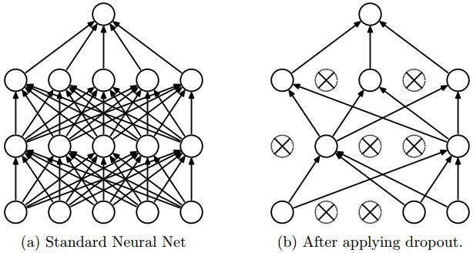As shown in Fig. 16, the model consists of five stack of layers. The layers include Convolutional layer, Activation layer, Max Pooling layer, Flatten layer, and dense layer and Dropout layer. The first three stacks consist of Convolutional layer, Activation layer and Max Pooling layer. The activation layer used is Rectified Linear Unit (ReLu). The fourth stack consists of Flatten layer, dense layer and Activation layer. After the first three layers, the output is in 3D and needs to be converted to 1D form. The Flatten layer is used to convert the 3D output to 1D format. The Dense layer is also known as Fully Connected layer. It is used to convert the matrix into a list format and all the nodes are connected to each other. The Activation layer used is Rectified Linear Unit (ReLu).

Figure 18: Dropout

The fifth stack consists of Dropout layer, dense layer and Activation layer. A fully connected layer occupies most of the parameters, and hence, neurons develop co-dependency amongst each other during training which curbs the individual power of each neuron leading to over-fitting of training data. The Dropout layer is used to remove the duplicate images present in the dataset to avoid system to undergo overfitting. The Activation layer used is Sigmoid. The sigmoid classification is best for binary classification problems such as gender. Generally, the network is trained using a larger and domain related dataset. After the convergence of the network parameters, an extra training step is done to optimize the network weights using in-domain data.

## Brief Explanation

To start with the project, the first step that needs to be done is data collection. Datasets play an important in deep learning as it is used to train the system to get the required output. Some datasets are available publicly while some are not. The UTKFace is a publicly available dataset which can be used for gender and age classification. This dataset has images of people of different age, gender and age. In the project, the dataset images are input into the algorithm to identify the gender.

The UTKFace dataset is used to train the model to perform gender and age classification. The input given is in the form of a face image and the image features are analysed based on the algorithm. An unknown image is then inputted to predict the gender and age of the same. An output will be generated which will contain the prediction of the unknown face image.

The UTKFace dataset is categorized into ‘Train’ and ‘Validation’, each of which contains ‘Male’ and ‘Female’. The project is trained using 8,000 images in each class and validated using 1,000 images in each class. The model is trained using ConvNet (Convolutional Neural Network) consisting of 2 layers. The CNN consists of many hidden layers such as Convolutional layer, ReLu layer, Max Pooling layer, Fully Connected layer, etc. Using these layers, the input face image is converted into weights and saved in ‘.h5’ format. These weights are then used to predict an unknown image. The average accuracy achieved in the project is 90%.

The training program includes data augmentation. Data augmentation means increasing the number of images in the dataset because plentiful high-quality information is the key to significant machine learning models. Foremost, training examples needs to be augmented via a variety of random transformations, so that the model would never see twice the exact same picture and this helps prevention of overfitting thereby generalizing model in a better way.

In the project, Keras is used to work on Tensorflow. Keras is an open source neural network library. It is user-friendly and provides many features like activation function, layers, optimizers, etc. Keras support both CNN and RNN. Using Java Virtual Machine (JVM), deep models can be created on iOS and Android. This can be achieved by using an appropriate class in keras. Convnet is the right tool for image classification. Data augmentation is a way to fight overfitting, however, it is not enough since the augmented samples are still highly correlated. The main focus for fighting overfitting must be the entropic capability i.e. the abundant information that the model is allowed to store. A model which can store a lot of information has the potential to be more accurate by leveraging more features in comparison to a model that can only store a few features. But the former is also more at risk as it will start storing irrelevant features whereas a model that can only store a few features will have to focus on the most significant features found within the data. The one which stores fewer features are more likely to be truly relevant and are easy to generalize. The setup for the project is as follows:

* 224,250 training examples (8000 per class)
* 5750 testing examples (1000 per class)

**Training** **Dataset**: The training dataset is a set of examples employed to train the model i.e. to fit the parameters. Most of the approaches used for training the samples tend to over fit if the dataset is not increased and used in variety.

**Test Dataset**: The test dataset is not dependent on the training or validation dataset. If a model is fitting both the training dataset as well as test dataset then it can be said that minimum overfitting has taken place. The test dataset is employed to check the performance characteristics like the accuracy, loss, sensitivity, etc.

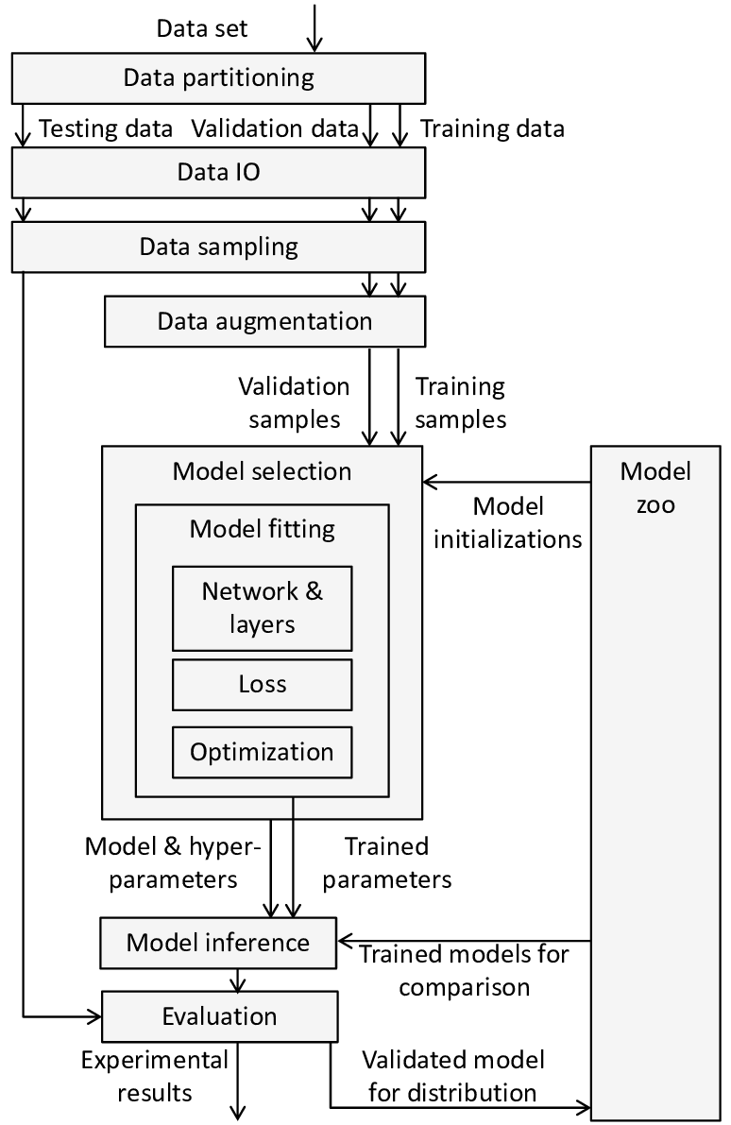

Figure 19: Processing

As shown in fig.19 the dataset is partitioned into two parts training and testing dataset. Training dataset consists of 75% of the whole dataset and the testing data comprises of 25%. Data sampling is done. Data sampling is a statistical analysis technique used to select, manipulate and analyse a representative subset of data points to identify patterns and trends in the larger data set being examine. There are two ways of sampling data as shown below.

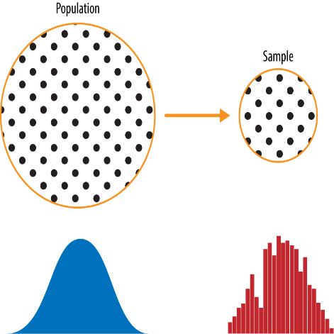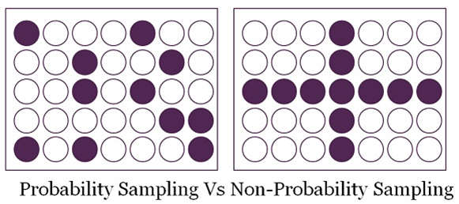

Figure 20: Sampling Of Data

Image augmentation is a very powerful technique used to artificially create variations in existing images to expand an existing image data set. This creates new and different images from the existing image data set that represents a comprehensive set of possible images. This helps to increase the performance of the model by generalizing better and thereby reducing overfitting. A CNN, due to its in-variance property, can classify objects even when visible in different sizes, orientations or different illumination.

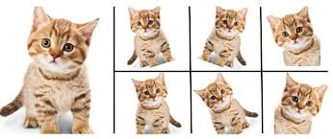

Figure 21: Augmentation of image by Keras

Keras permits the model to perform random transformations and normalization operations on batches of image data. The attributes used are rotation range, width shift and height shift, rescale, shear range, zoom range, horizontal rip and fill mode. By using these attributes, the system can automatically rotate pictures, translate pictures, rescale pictures, zoom into pictures, apply shearing transformations, rip images horizontally, fill newly created pixels, etc.

After this the data is inputted in the model and passes through different layers of neural network and gets trained Machine learn by means of a loss function. It’s a method of evaluating how well specific algorithm models the given data. If predictions deviates too much from actual results, loss function would cough up a very large number. Broadly, loss functions can be classified into two major categories depending upon the type of learning task we are dealing with Regression losses and Classification losses.

Deep learning is a highly iterative process. We have to try out various permutations of the hyper parameters to figure out which combination works best. Therefore it is crucial that our deep learning model trains in a shorter time without penalizing the cost. Gradually, with the help of some optimization function, loss function learns to reduce the error in prediction. The performance of the optimization algorithm directly affects the model's training efficiency.

The model is tested with validation dataset through the process and a visual representation is used to show the progress in learning process of the model.

### Methodology Used

The methodology used is Iterative waterfall model. In this model, the software development activities move to the next phase only after the activities in the current phase are over. However, unlike in the case with a waterfall model, one cannot return to the previous stage in case of Iterative Waterfall Model.

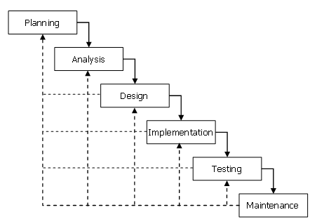

Figure 22: Diagram showing Water Fall Model

The most important advantage of the iterative waterfall model lies in the fact, that there is minimum planning overhead for the steps that are to follow, since the activities in each of the phase is carried out upfront, it is feasible that one does not have to plan for the entire phase. The most important of the advantage is that the project does not slip on its schedule. The number of resources working on the project does not keep on increasing with each passing day, as the planning for the same is done at the start of the phase itself.

## Graphs and Diagrams

### Data Visualization

Visualization of the performance of any machine learning model is an easy way to make sense of the data being poured out of the model and make an informed decision about the changes that need to be made on the parameters or hyper parameters that affects the Machine Learning model.

**Reasons to Visualize**

* To evaluate the Under fitting or Overfitting: Visualizing the training loss vs. validation loss or training accuracy vs. validation accuracy over a number of epochs is a good way to determine if the model has been sufficiently trained. This is important so that the model is not undertrained and not over trained such that it starts memorizing the training data which will, in turn, reduce its ability to predict accurately.
* 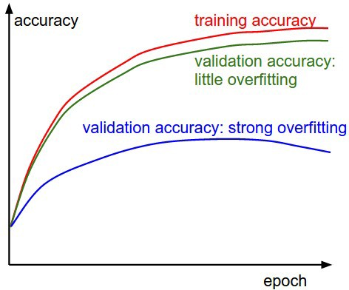To adjust the Hyper parameters: Hyper parameters such as the number of nodes per layer of the Neural Network and the number of layers in the Network can make a significant impact on the performance of the Model. Visualization of the fitness of the training and validation set data can help to optimize these values and in building a better model.

Figure 23: Visualisation Curves

#### Loss Curve

One of the most used plots to debug a neural network is a Loss curve during training. It gives us a snapshot of the training process and the direction in which the network learns. A loss function is used to optimize a machine learning algorithm. The loss is calculated on training and validation and its interpretation is based on how well the model is doing in these two sets. It is the sum of errors made for each example in training or validation sets. Loss value implies how poorly or well a model behaves after each iteration of optimization.

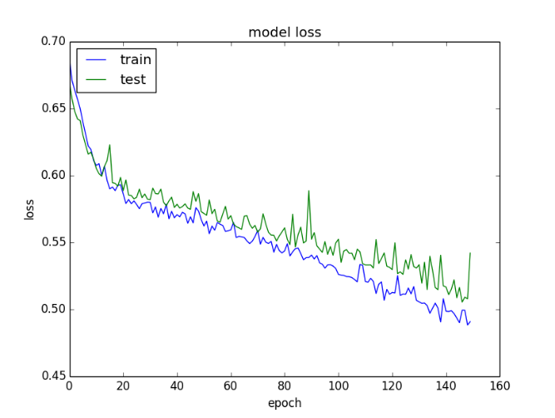

Figure 24: Loss Curve

#### Accuracy Graph

After building a model on a training set, to ensure that the model is not an overfit for the data, the test set was used to evaluate the model accuracy. An accuracy metric is used to measure the algorithm’s performance in an interpretable way. The accuracy of a model is usually determined after the model parameters and is calculated in the form of a percentage. It is the measure of how accurate your model's prediction is compared to the true data.

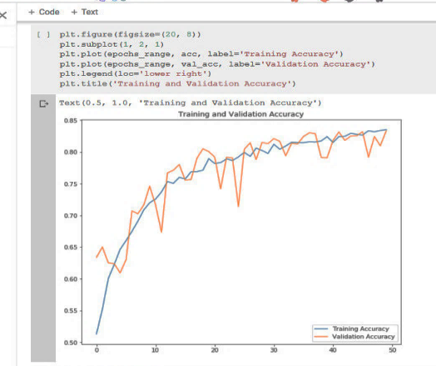

Figure 25: Training and validation accuracy graph

### E R Diagram

ENTITY-RELATIONSHIP DIAGRAM (ERD) displays the relationships of entity set stored in a database. In other words, we can say that ER diagrams help you to explain the logical structure of databases. At first look, an ER diagram looks very similar to the flowchart. However, ER Diagram includes many specialized symbols, and its meanings make this model unique. The purpose of ER Diagram is to represent the entity framework infrastructure. Here, are prime reasons for using the ER Diagram:-

* Provide a preview of how all your tables should connect, what fields are going to be on each table.
* Helps to describe entities, attributes, relationships.
* ER diagrams are translatable into relational tables which allows you to build databases quickly.
* ER diagrams can be used by database designers as a blueprint for implementing data in specific software applications.
* The database designer gains a better understanding of the information to be contained in the database with the help of ERP diagram.
* ERD is allowed you to communicate with the logical structure of the database to users.

As mentioned earlier the applications contain a subscription page, the page contains a number of entries which needs to be filed by the user. E R diagram in Fig 20 shows details of the subscription page.

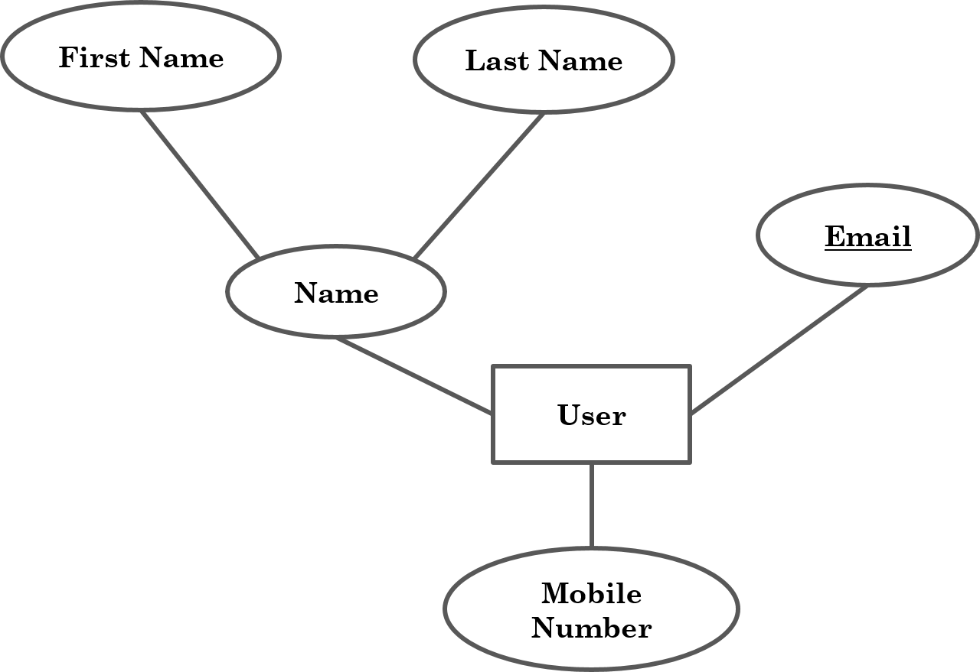

Figure 26: E R Diagram

ER- Diagram is a visual representation of data that describe how data is related to each other. The rectangle represents the entity type which is user in this case. Text enclosed in ellipse symbol represent attributes, name, mobile number, Email are various attributes. Here name is a multivalued attribute consisting first and last name. Underlined attributes are known as Primary Key. In the relational model of databases, a primary key is a specific choice of a minimal set of attributes that uniquely specify a tuple in a relation. Informally, a primary key is "which attributes identify a record", and in simple cases are simply a single attribute: a unique id. Lines are used to link the attributes to entity type and to other relation.

### Data Flow Diagram

A data-flow diagram is a way of representing a flow of data through a process or a system. The DFD also provides information about the outputs and inputs of each entity and the process itself. A data-flow diagram has no control flow, there are no decision rules and no loops. The following diagram shows the division and flow of dataset used in this project.

Training Phase Testing Phase

Figure 27: Diagram representing DFD of Model

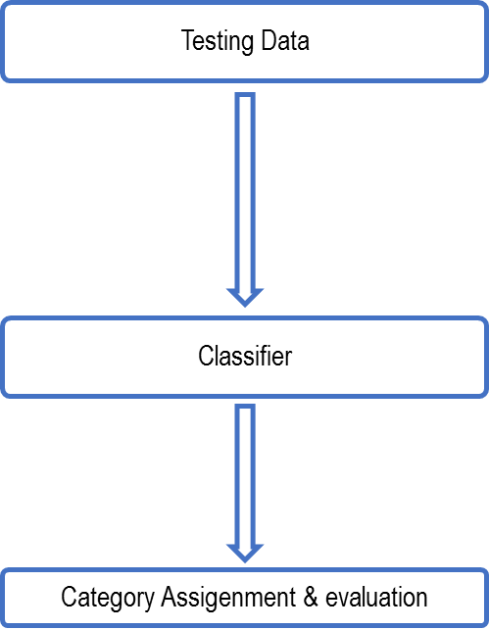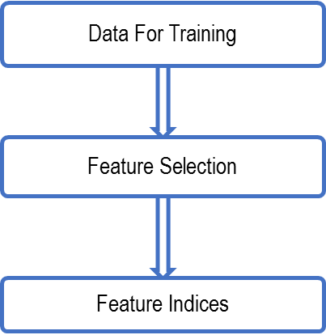

## Requirments Specification

Requirement Analysis is the first technical step in the software engineering process. It is at this point that a general statement of software scope is refined into a concrete specification that becomes a foundation for all the software engineering activities that follow. Analysis must focus on the informational, functional, and behavioural domains of a problem. To better understand what is required, models are created, the problem is partitioned, and representation that depict the essence of requirements and later, implementation detail, are developed.

### Hardware Requirement:

* **Processor** : fourth generation intel core i3
* **Speed** : 1.7 GHz.
* **RAM** : 4 GB (minimum) OR more
* **Hard Disk** : 20 GB
* **Key Board** : Standard Windows Keyboard
* **Mobile**  : Mobile with Android Operating System

### Software Requirement:

* **Operating System** : Windows
* **Database**  :
* **IDE** :
* **Network** : High speed Internet with minimum 10kbp pr sec

# IMPLEMENTATION

## Module Description

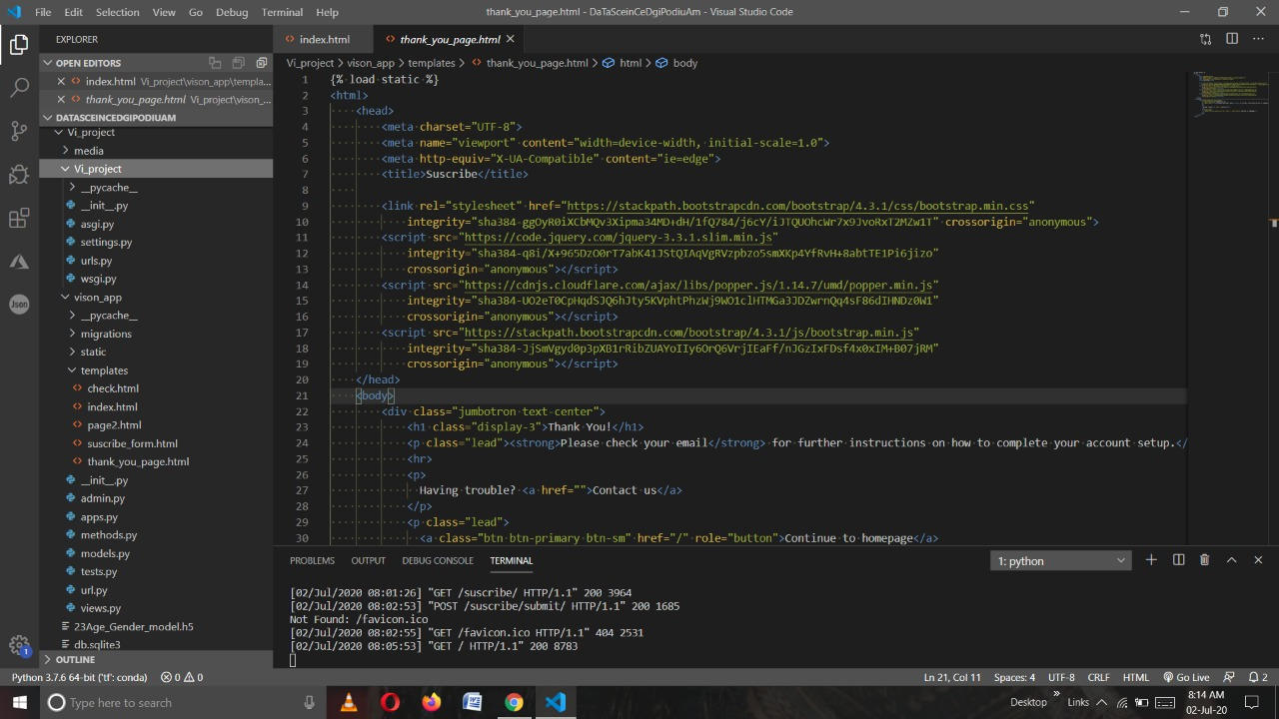

Figure : Model Files

### View.py

from django.shortcuts import render

from django.http import HttpResponse

from django.http import HttpResponseRedirect

from django.views.decorators.csrf import csrf_exempt

from django.conf import settings

from django.conf.urls.static import static

from django.core.files.storage import FileSystemStorage

import pandas as pd

import numpy as np

import os

import cv2

import keras

import keras.backend.tensorflow_backend as tb

from vison_app import methods

from .models import Suscribe

@csrf_exempt

def homePage(request):

return render(request,'index.html')

@csrf_exempt

def suscribe_form(request):

return render(request,'suscribe_form.html')

@csrf_exempt

def suscribe(request):

name = request.POST["name"]

last_name = request.POST["last_name"]

email = request.POST["email"]

data = Suscribe(name = name, middleName = last_name, email = email)

data.save()

return render(request,'thank_you_page.html')

@csrf_exempt

def pic_upload(request):

try:

file=request.FILES['myfile']

fs = FileSystemStorage()

filename = fs.save(file.name, file)

upload_url=fs.url(filename)

path = "Vi_project/media/"+file.name

output= methods.read_photo(path)

if output != "No_face" and output != "Multiple_face":

try:

gender,age = methods.predition_age_gender(output)

return render(request,'page2.html',{'pic_name':upload_url,'age':age,'gender':gender})

except Exception as error:

return render(request,'page2.html',{'error':str(error),'pic_name':upload_url})

else:

return render(request,'page2.html',{'error':output,'pic_name':upload_url})

except:

return HttpResponseRedirect("/")

### Model.py

Contains the database schema

from django.db import models

class Suscribe(models.Model):

name = models.CharField(max_length=200)

middleName = models.CharField(max_length=100)

email = models.EmailField()

def _str_(self):

return self.name

class suscribe_in(models.Model):

suscribe = models.CharField(max_length=200)

def _str_(self):

return self.suscribe

### Methods.py

Contains all functions and provide reusability of code for the model

import json

import os

import cv2

import numpy as np

import pandas as pd

import tensorflow as tf

from keras import backend as K

from keras.models import load_model

# Create your models here.

def load_model_from_path():

graph = tf.get_default_graph()

model = load_model('Vi_project/23Age_Gender_model.h5')

return graph,model

def read_photo(path):

imm = cv2.imread(path,cv2.IMREAD_COLOR)

if imm.any():

gray = cv2.cvtColor(imm, cv2.COLOR_RGB2GRAY)

faceCascade = cv2.CascadeClassifier(cv2.data.haarcascades + "haarcascade_frontalface_default.xml")

faces = faceCascade.detectMultiScale(

gray,

scaleFactor=1.3,

minNeighbors=3,

minSize=(60, 60)

)

if len(faces)==1:

for (x, y, w, h) in faces:

cv2.rectangle(imm, (x, y), (x + w, y + h), (0, 255, 0), 2)

roi_color = imm[y:y + h, x:x + w]

return roi_color

elif len(faces)==0:

return("No_face")

else:

return("Multiple_face")

return None

def predition_age_gender(X):

graph,model = load_model_from_path()

X_data =[]

face = cv2.cvtColor(X, cv2.COLOR_BGR2RGB)

face =cv2.resize(face, (32,32) )

X_data.append(face)

X_data=np.array(X_data)

try:

with graph.as_default():

predictions = model.predict(X_data)

gender = predictions[0]

gender = "Female" if gender>0.5 else "Male"

age = int(predictions[1])

return gender,age

except Exception as err:

raise(err)

return None

### Url.py

Also known as local url file which contains all urls

from django.conf.urls import include

from django.urls import path

from .import views

urlpatterns = [

path('submit/',views.suscribe,name='suscribe'),

]

### Urls.py

"""Vi_project URL Configuration

The `urlpatterns` list routes URLs to views. For more information please see:

https://docs.djangoproject.com/en/3.0/topics/http/urls/

Examples:

Function views

1. Add an import: from my_app import views

2. Add a URL to urlpatterns: path('', views.home, name='home')

Class-based views

1. Add an import: from other_app.views import Home

2. Add a URL to urlpatterns: path('', Home.as_view(), name='home')

Including another URLconf

1. Import the include() function: from django.urls import include, path

2. Add a URL to urlpatterns: path('blog/', include('blog.urls'))

"""

#_SYMBOLIC_SCOPE.value = True

from django.contrib import admin

from django.urls import path

from vison_app import views

from django.conf import settings

from django.conf.urls.static import static

from django.conf.urls import include, url

urlpatterns = [

path('admin/', admin.site.urls),

path('',views.homePage),

path('pic_upload/',views.pic_upload),

path('suscribe/',views.suscribe_form),

path('suscribe/',include('vison_app.url'))

]

if settings.DEBUG:

urlpatterns += static(settings.MEDIA_URL, document_root=settings.MEDIA_ROOT)

## Training

### Generation of model

def gen_model():

inputs = keras.layers.Input(shape=(32, 32, 3))

x = inputs

x = layers.Conv2D(32,3,activation='relu')(x)

x = layers.Conv2D(32,3,activation='relu')(x)

x = layers.MaxPool2D(2)(x)

x = layers.Dropout(0.3)(x)

x = layers.Conv2D(64,3,activation='relu')(x)

x = layers.Conv2D(64,3,activation='relu')(x)

x = layers.MaxPool2D(2)(x)

x = layers.Dropout(0.3)(x)

x = layers.Conv2D(84,3,activation='relu')(x)

x = layers.Dropout(0.3)(x)

x = layers.Flatten()(x)

x1 = layers.Dense(64,activation='relu')(x)

x2 = layers.Dense(64,activation='relu')(x)

x1 = layers.Dense(1,activation='sigmoid',name='sex_out')(x1)

x2 = layers.Dense(1,activation='relu',name='age_out')(x2)

model = keras.models.Model(inputs=inputs, outputs=[x1, x2])

model.compile(optimizer='Adam', loss=['binary_crossentropy','mae'])

return model

model=gen_model()

If model fails or stops while training it is made to re start from the point it stopped.

import random

random_id=random.random()

model.summary()

callbacks = [

keras.callbacks.EarlyStopping(patience=75, monitor='val_loss',restore_best_weights=True),

keras.callbacks.TensorBoard(log_dir='./logs/'+str(random_id))

]

### Partitioning of dataset

X_train, X_valid, y_train, y_valid = train_test_split(X, y, test_size=0.33)

y_train=[y_train[:,1],y_train[:,0]]

y_valid=[y_valid[:,1],y_valid[:,0]]

### Training the model

model.fit(X_train, y_train, epochs=2000,batch_size=240,validation_data=(X_valid,y_valid),callbacks=callbacks, shuffle=True)

Model: "model_2"

__________________________________

Layer (type) Output Shape Param # Connected to

==================================================================================================

input_6 (InputLayer) (None, 32, 32, 3) 0

__________________________________

conv2d_58 (Conv2D) (None, 30, 30, 32) 896 input_6[0][0]

__________________________________

conv2d_59 (Conv2D) (None, 28, 28, 32) 9248 conv2d_58[0][0]

__________________________________

max_pooling2d_55 (MaxPooling2D) (None, 14, 14, 32) 0 conv2d_59[0][0]

__________________________________

dropout_4 (Dropout) (None, 14, 14, 32) 0 max_pooling2d_55[0][0]

__________________________________

conv2d_60 (Conv2D) (None, 12, 12, 64) 18496 dropout_4[0][0]

__________________________________

conv2d_61 (Conv2D) (None, 10, 10, 64) 36928 conv2d_60[0][0]

__________________________________

max_pooling2d_56 (MaxPooling2D) (None, 5, 5, 64) 0 conv2d_61[0][0]

__________________________________

dropout_5 (Dropout) (None, 5, 5, 64) 0 max_pooling2d_56[0][0]

__________________________________

conv2d_62 (Conv2D) (None, 3, 3, 84) 48468 dropout_5[0][0]

__________________________________

dropout_6 (Dropout) (None, 3, 3, 84) 0 conv2d_62[0][0]

__________________________________

flatten_15 (Flatten) (None, 756) 0 dropout_6[0][0]

__________________________________

dense_29 (Dense) (None, 64) 48448 flatten_15[0][0]

__________________________________

dense_30 (Dense) (None, 64) 48448 flatten_15[0][0]

__________________________________

sex_out (Dense) (None, 1) 65 dense_29[0][0]

__________________________________

age_out (Dense) (None, 1) 65 dense_30[0][0]

==================================================================================================

Total params: 211,062

Trainable params: 211,062

Non-trainable params: 0

Epoch 1/2000

6700/6700 [==============================] - 25s 4ms/step - loss: 28.5326 - sex_out_loss: 3.4093 - age_out_loss: 25.1233 - val_loss: 24.5617 - val_sex_out_loss: 0.6668 - val_age_out_loss: 23.8949

Epoch 2/2000

6700/6700 [==============================] - 24s 4ms/step - loss: 19.3499 - sex_out_loss: 1.0848 - age_out_loss: 18.2651 - val_loss: 26.3602 - val_sex_out_loss: 0.6687 - val_age_out_loss: 25.6914

Epoch 3/2000

6700/6700 [==============================] - 24s 4ms/step - loss: 18.1767 - sex_out_loss: 0.7790 - age_out_loss: 17.3977 - val_loss: 25.3633 - val_sex_out_loss: 0.6731 - val_age_out_loss: 24.6902

Epoch 4/2000

6700/6700 [==============================] - 24s 4ms/step - loss: 17.7251 - sex_out_loss: 0.7042 - age_out_loss: 17.0210 - val_loss: 22.0025 - val_sex_out_loss: 0.6496 - val_age_out_loss: 21.3529

Epoch 5/2000

6700/6700 [==============================] - 25s 4ms/step - loss: 17.1362 - sex_out_loss: 0.6677 - age_out_loss: 16.4685 - val_loss: 23.5965 - val_sex_out_loss: 0.6253 - val_age_out_loss: 22.9712

Epoch 6/2000

6700/6700 [==============================] - 24s 4ms/step - loss: 16.1709 - sex_out_loss: 0.6314 - age_out_loss: 15.5395 - val_loss: 21.1332 - val_sex_out_loss: 0.5838 - val_age_out_loss: 20.5494

Epoch 7/2000

6700/6700 [==============================] - 24s 4ms/step - loss: 15.3317 - sex_out_loss: 0.5970 - age_out_loss: 14.7348 - val_loss: 16.1989 - val_sex_out_loss: 0.5401 - val_age_out_loss: 15.6588

Epoch 8/2000

6700/6700 [==============================] - 24s 4ms/step - loss: 14.8960 - sex_out_loss: 0.5787 - age_out_loss: 14.3174 - val_loss: 15.7071 - val_sex_out_loss: 0.5405 - val_age_out_loss: 15.1666

Epoch 9/2000

6700/6700 [==============================] - 24s 4ms/step - loss: 13.7211 - sex_out_loss: 0.5814 - age_out_loss: 13.1398 - val_loss: 15.6042 - val_sex_out_loss: 0.5624 - val_age_out_loss: 15.0418

Epoch 10/2000

6700/6700 [==============================] - 24s 4ms/step - loss: 13.6535 - sex_out_loss: 0.5640 - age_out_loss: 13.0894 - val_loss: 14.5783 - val_sex_out_loss: 0.5268 - val_age_out_loss: 14.0515

Epoch 11/2000

6700/6700 [==============================] - 24s 4ms/step - loss: 13.0315 - sex_out_loss: 0.5599 - age_out_loss: 12.4716 - val_loss: 15.0227 - val_sex_out_loss: 0.5174 - val_age_out_loss: 14.5053

Epoch 12/2000

6700/6700 [==============================] - 24s 4ms/step - loss: 12.6417 - sex_out_loss: 0.5521 - age_out_loss: 12.0896 - val_loss: 15.3627 - val_sex_out_loss: 0.5218 - val_age_out_loss: 14.8409

Epoch 13/2000

6700/6700 [==============================] - 24s 4ms/step - loss: 12.2396 - sex_out_loss: 0.5348 - age_out_loss: 11.7048 - val_loss: 12.2651 - val_sex_out_loss: 0.4901 - val_age_out_loss: 11.7749

Epoch 14/2000

6700/6700 [==============================] - 24s 4ms/step - loss: 12.0046 - sex_out_loss: 0.5292 - age_out_loss: 11.4754 - val_loss: 14.9642 - val_sex_out_loss: 0.4930 - val_age_out_loss: 14.4712

Epoch 15/2000

6700/6700 [==============================] - 24s 4ms/step - loss: 11.4665 - sex_out_loss: 0.5222 - age_out_loss: 10.9442 - val_loss: 15.8622 - val_sex_out_loss: 0.4874 - val_age_out_loss: 15.3748

Epoch 16/2000

6700/6700 [==============================] - 24s 4ms/step - loss: 11.9636 - sex_out_loss: 0.5109 - age_out_loss: 11.4526 - val_loss: 12.4321 - val_sex_out_loss: 0.4794 - val_age_out_loss: 11.9527

Epoch 17/2000

6700/6700 [==============================] - 24s 4ms/step - loss: 11.3299 - sex_out_loss: 0.4982 - age_out_loss: 10.8317 - val_loss: 12.5402 - val_sex_out_loss: 0.4568 - val_age_out_loss: 12.0834

Epoch 18/2000

6700/6700 [==============================] - 24s 4ms/step - loss: 11.3257 - sex_out_loss: 0.4996 - age_out_loss: 10.8262 - val_loss: 13.7011 - val_sex_out_loss: 0.4478 - val_age_out_loss: 13.2533

Epoch 19/2000

6700/6700 [==============================] - 24s 4ms/step - loss: 11.1191 - sex_out_loss: 0.4895 - age_out_loss: 10.6296 - val_loss: 14.2399 - val_sex_out_loss: 0.4465 - val_age_out_loss: 13.7934

Epoch 20/2000

6700/6700 [==============================] - 24s 4ms/step - loss: 10.8082 - sex_out_loss: 0.4844 - age_out_loss: 10.3237 - val_loss: 14.7130 - val_sex_out_loss: 0.4350 - val_age_out_loss: 14.2780

Epoch 21/2000

6700/6700 [==============================] - 24s 4ms/step - loss: 10.7476 - sex_out_loss: 0.4751 - age_out_loss: 10.2725 - val_loss: 12.7036 - val_sex_out_loss: 0.4258 - val_age_out_loss: 12.2778

Epoch 22/2000

6700/6700 [==============================] - 24s 4ms/step - loss: 10.4718 - sex_out_loss: 0.4665 - age_out_loss: 10.0053 - val_loss: 11.3790 - val_sex_out_loss: 0.4203 - val_age_out_loss: 10.9587

Epoch 23/2000

6700/6700 [==============================] - 24s 4ms/step - loss: 10.5679 - sex_out_loss: 0.4634 - age_out_loss: 10.1045 - val_loss: 11.0901 - val_sex_out_loss: 0.4082 - val_age_out_loss: 10.6819

Epoch 24/2000

6700/6700 [==============================] - 24s 4ms/step - loss: 10.6992 - sex_out_loss: 0.4699 - age_out_loss: 10.2292 - val_loss: 11.9739 - val_sex_out_loss: 0.4206 - val_age_out_loss: 11.5533

Epoch 25/2000

6700/6700 [==============================] - 24s 4ms/step - loss: 10.2402 - sex_out_loss: 0.4607 - age_out_loss: 9.7795 - val_loss: 15.3458 - val_sex_out_loss: 0.4395 - val_age_out_loss: 14.9063

Epoch 26/2000

6700/6700 [==============================] - 25s 4ms/step - loss: 10.4916 - sex_out_loss: 0.4634 - age_out_loss: 10.0282 - val_loss: 13.1395 - val_sex_out_loss: 0.4026 - val_age_out_loss: 12.7368

Epoch 27/2000

6700/6700 [==============================] - 24s 4ms/step - loss: 9.9566 - sex_out_loss: 0.4413 - age_out_loss: 9.5153 - val_loss: 11.9963 - val_sex_out_loss: 0.4072 - val_age_out_loss: 11.5891

Epoch 28/2000

6700/6700 [==============================] - 24s 4ms/step - loss: 10.2284 - sex_out_loss: 0.4483 - age_out_loss: 9.7801 - val_loss: 15.5273 - val_sex_out_loss: 0.4026 - val_age_out_loss: 15.1247

Epoch 29/2000

6700/6700 [==============================] - 24s 4ms/step - loss: 10.1316 - sex_out_loss: 0.4332 - age_out_loss: 9.6984 - val_loss: 12.1151 - val_sex_out_loss: 0.3883 - val_age_out_loss: 11.7269

Epoch 30/2000

6700/6700 [==============================] - 24s 4ms/step - loss: 9.7303 - sex_out_loss: 0.4416 - age_out_loss: 9.2887 - val_loss: 12.9564 - val_sex_out_loss: 0.3864 - val_age_out_loss: 12.5700

Epoch 31/2000

6700/6700 [==============================] - 24s 4ms/step - loss: 9.6458 - sex_out_loss: 0.4428 - age_out_loss: 9.2030 - val_loss: 14.4288 - val_sex_out_loss: 0.4042 - val_age_out_loss: 14.0246

Epoch 32/2000

6700/6700 [==============================] - 24s 4ms/step - loss: 9.5919 - sex_out_loss: 0.4387 - age_out_loss: 9.1532 - val_loss: 13.6327 - val_sex_out_loss: 0.4014 - val_age_out_loss: 13.2313

Epoch 33/2000

6700/6700 [==============================] - 24s 4ms/step - loss: 9.4412 - sex_out_loss: 0.4304 - age_out_loss: 9.0109 - val_loss: 13.4573 - val_sex_out_loss: 0.3968 - val_age_out_loss: 13.0605

Epoch 34/2000

6700/6700 [==============================] - 24s 4ms/step - loss: 9.5946 - sex_out_loss: 0.4202 - age_out_loss: 9.1744 - val_loss: 10.1899 - val_sex_out_loss: 0.3851 - val_age_out_loss: 9.8048

Epoch 35/2000

6700/6700 [==============================] - 24s 4ms/step - loss: 9.4297 - sex_out_loss: 0.4171 - age_out_loss: 9.0126 - val_loss: 13.1912 - val_sex_out_loss: 0.3740 - val_age_out_loss: 12.8172

Epoch 36/2000

6700/6700 [==============================] - 24s 4ms/step - loss: 9.4241 - sex_out_loss: 0.4220 - age_out_loss: 9.0021 - val_loss: 12.3395 - val_sex_out_loss: 0.3767 - val_age_out_loss: 11.9628

Epoch 37/2000

6700/6700 [==============================] - 24s 4ms/step - loss: 9.5010 - sex_out_loss: 0.4243 - age_out_loss: 9.0767 - val_loss: 15.2353 - val_sex_out_loss: 0.3842 - val_age_out_loss: 14.8511

Epoch 38/2000

6700/6700 [==============================] - 24s 4ms/step - loss: 9.4884 - sex_out_loss: 0.4186 - age_out_loss: 9.0697 - val_loss: 12.2915 - val_sex_out_loss: 0.3775 - val_age_out_loss: 11.9140

Epoch 39/2000

6700/6700 [==============================] - 24s 4ms/step - loss: 9.2895 - sex_out_loss: 0.4112 - age_out_loss: 8.8783 - val_loss: 14.0048 - val_sex_out_loss: 0.3740 - val_age_out_loss: 13.6308

Epoch 40/2000

6700/6700 [==============================] - 24s 4ms/step - loss: 9.4554 - sex_out_loss: 0.4116 - age_out_loss: 9.0439 - val_loss: 15.8713 - val_sex_out_loss: 0.3755 - val_age_out_loss: 15.4958

Epoch 41/2000

6700/6700 [==============================] - 24s 4ms/step - loss: 9.4379 - sex_out_loss: 0.4147 - age_out_loss: 9.0232 - val_loss: 11.9957 - val_sex_out_loss: 0.3685 - val_age_out_loss: 11.6272

Epoch 42/2000

6700/6700 [==============================] - 24s 4ms/step - loss: 9.0477 - sex_out_loss: 0.4107 - age_out_loss: 8.6370 - val_loss: 11.8257 - val_sex_out_loss: 0.3793 - val_age_out_loss: 11.4465

Epoch 43/2000

6700/6700 [==============================] - 24s 4ms/step - loss: 8.7804 - sex_out_loss: 0.4115 - age_out_loss: 8.3689 - val_loss: 10.9773 - val_sex_out_loss: 0.3712 - val_age_out_loss: 10.6061

Epoch 44/2000

6700/6700 [==============================] - 24s 4ms/step - loss: 8.6453 - sex_out_loss: 0.4014 - age_out_loss: 8.2439 - val_loss: 13.4497 - val_sex_out_loss: 0.3646 - val_age_out_loss: 13.0851

Epoch 45/2000

6700/6700 [==============================] - 24s 4ms/step - loss: 8.9189 - sex_out_loss: 0.4057 - age_out_loss: 8.5132 - val_loss: 12.6693 - val_sex_out_loss: 0.3619 - val_age_out_loss: 12.3074

Epoch 46/2000

6700/6700 [==============================] - 24s 4ms/step - loss: 8.8543 - sex_out_loss: 0.4008 - age_out_loss: 8.4534 - val_loss: 12.0197 - val_sex_out_loss: 0.3617 - val_age_out_loss: 11.6580

Epoch 47/2000

6700/6700 [==============================] - 24s 4ms/step - loss: 8.9497 - sex_out_loss: 0.4009 - age_out_loss: 8.5488 - val_loss: 11.3023 - val_sex_out_loss: 0.3554 - val_age_out_loss: 10.9469

Epoch 48/2000

6700/6700 [==============================] - 24s 4ms/step - loss: 8.6011 - sex_out_loss: 0.3998 - age_out_loss: 8.2013 - val_loss: 11.8083 - val_sex_out_loss: 0.3651 - val_age_out_loss: 11.4431

Epoch 49/2000

6700/6700 [==============================] - 24s 4ms/step - loss: 8.7430 - sex_out_loss: 0.4031 - age_out_loss: 8.3399 - val_loss: 10.4842 - val_sex_out_loss: 0.3566 - val_age_out_loss: 10.1276

Epoch 50/2000

6700/6700 [==============================] - 24s 4ms/step - loss: 8.8291 - sex_out_loss: 0.3924 - age_out_loss: 8.4367 - val_loss: 12.2981 - val_sex_out_loss: 0.3593 - val_age_out_loss: 11.9387

Epoch 51/2000

6700/6700 [==============================] - 24s 4ms/step - loss: 8.4162 - sex_out_loss: 0.3965 - age_out_loss: 8.0197 - val_loss: 11.4368 - val_sex_out_loss: 0.3497 - val_age_out_loss: 11.0871

Epoch 52/2000

6700/6700 [==============================] - 24s 4ms/step - loss: 8.7157 - sex_out_loss: 0.3865 - age_out_loss: 8.3292 - val_loss: 10.6350 - val_sex_out_loss: 0.3594 - val_age_out_loss: 10.2756

Epoch 53/2000

6700/6700 [==============================] - 24s 4ms/step - loss: 8.5031 - sex_out_loss: 0.3862 - age_out_loss: 8.1168 - val_loss: 11.2426 - val_sex_out_loss: 0.3511 - val_age_out_loss: 10.8915

Epoch 54/2000

6700/6700 [==============================] - 24s 4ms/step - loss: 8.3442 - sex_out_loss: 0.3930 - age_out_loss: 7.9513 - val_loss: 12.4296 - val_sex_out_loss: 0.3558 - val_age_out_loss: 12.0738

Epoch 55/2000

6700/6700 [==============================] - 24s 4ms/step - loss: 8.3584 - sex_out_loss: 0.3778 - age_out_loss: 7.9806 - val_loss: 12.9380 - val_sex_out_loss: 0.3565 - val_age_out_loss: 12.5815

Epoch 56/2000

6700/6700 [==============================] - 24s 4ms/step - loss: 8.6795 - sex_out_loss: 0.3923 - age_out_loss: 8.2871 - val_loss: 12.6082 - val_sex_out_loss: 0.3538 - val_age_out_loss: 12.2544

Epoch 57/2000

6700/6700 [==============================] - 24s 4ms/step - loss: 8.5503 - sex_out_loss: 0.3781 - age_out_loss: 8.1722 - val_loss: 13.1607 - val_sex_out_loss: 0.3503 - val_age_out_loss: 12.8104

Epoch 58/2000

6700/6700 [==============================] - 24s 4ms/step - loss: 8.2032 - sex_out_loss: 0.3849 - age_out_loss: 7.8183 - val_loss: 10.4161 - val_sex_out_loss: 0.3638 - val_age_out_loss: 10.0523

Epoch 59/2000

6700/6700 [==============================] - 24s 4ms/step - loss: 8.1588 - sex_out_loss: 0.3808 - age_out_loss: 7.7779 - val_loss: 9.1041 - val_sex_out_loss: 0.3372 - val_age_out_loss: 8.7669

Epoch 60/2000

6700/6700 [==============================] - 24s 4ms/step - loss: 8.3384 - sex_out_loss: 0.3710 - age_out_loss: 7.9674 - val_loss: 10.3142 - val_sex_out_loss: 0.3643 - val_age_out_loss: 9.9500

Epoch 61/2000

6700/6700 [==============================] - 24s 4ms/step - loss: 8.2738 - sex_out_loss: 0.3920 - age_out_loss: 7.8818 - val_loss: 11.4123 - val_sex_out_loss: 0.3507 - val_age_out_loss: 11.0616

Epoch 62/2000

6700/6700 [==============================] - 24s 4ms/step - loss: 8.3028 - sex_out_loss: 0.3859 - age_out_loss: 7.9169 - val_loss: 9.7152 - val_sex_out_loss: 0.3411 - val_age_out_loss: 9.3741

Epoch 63/2000

6700/6700 [==============================] - 24s 4ms/step - loss: 7.9730 - sex_out_loss: 0.3782 - age_out_loss: 7.5948 - val_loss: 10.5901 - val_sex_out_loss: 0.3422 - val_age_out_loss: 10.2479

Epoch 64/2000

6700/6700 [==============================] - 25s 4ms/step - loss: 8.0695 - sex_out_loss: 0.3774 - age_out_loss: 7.6921 - val_loss: 11.1465 - val_sex_out_loss: 0.3613 - val_age_out_loss: 10.7852

Epoch 65/2000

6700/6700 [==============================] - 24s 4ms/step - loss: 8.0463 - sex_out_loss: 0.3891 - age_out_loss: 7.6572 - val_loss: 12.0078 - val_sex_out_loss: 0.3676 - val_age_out_loss: 11.6401

Epoch 66/2000

6700/6700 [==============================] - 24s 4ms/step - loss: 8.0256 - sex_out_loss: 0.3711 - age_out_loss: 7.6546 - val_loss: 11.2449 - val_sex_out_loss: 0.3392 - val_age_out_loss: 10.9057

Epoch 67/2000

6700/6700 [==============================] - 24s 4ms/step - loss: 7.7734 - sex_out_loss: 0.3748 - age_out_loss: 7.3985 - val_loss: 9.9378 - val_sex_out_loss: 0.3418 - val_age_out_loss: 9.5961

Epoch 68/2000

6700/6700 [==============================] - 24s 4ms/step - loss: 7.6671 - sex_out_loss: 0.3762 - age_out_loss: 7.2909 - val_loss: 10.9024 - val_sex_out_loss: 0.3406 - val_age_out_loss: 10.5618

Epoch 69/2000

6700/6700 [==============================] - 24s 4ms/step - loss: 8.5585 - sex_out_loss: 0.3823 - age_out_loss: 8.1763 - val_loss: 13.2991 - val_sex_out_loss: 0.3607 - val_age_out_loss: 12.9384

Epoch 70/2000

6700/6700 [==============================] - 24s 4ms/step - loss: 7.8815 - sex_out_loss: 0.3771 - age_out_loss: 7.5044 - val_loss: 10.0928 - val_sex_out_loss: 0.3356 - val_age_out_loss: 9.7572

Epoch 71/2000

6700/6700 [==============================] - 24s 4ms/step - loss: 7.6604 - sex_out_loss: 0.3652 - age_out_loss: 7.2952 - val_loss: 9.9195 - val_sex_out_loss: 0.3371 - val_age_out_loss: 9.5825

Epoch 72/2000

6700/6700 [==============================] - 24s 4ms/step - loss: 7.6632 - sex_out_loss: 0.3650 - age_out_loss: 7.2982 - val_loss: 10.7414 - val_sex_out_loss: 0.3335 - val_age_out_loss: 10.4078

Epoch 73/2000

6700/6700 [==============================] - 24s 4ms/step - loss: 7.7693 - sex_out_loss: 0.3635 - age_out_loss: 7.4058 - val_loss: 11.4377 - val_sex_out_loss: 0.3452 - val_age_out_loss: 11.0925

Epoch 74/2000

6700/6700 [==============================] - 24s 4ms/step - loss: 8.0074 - sex_out_loss: 0.3742 - age_out_loss: 7.6332 - val_loss: 8.7869 - val_sex_out_loss: 0.3449 - val_age_out_loss: 8.4420

Epoch 75/2000

6700/6700 [==============================] - 24s 4ms/step - loss: 7.7302 - sex_out_loss: 0.3659 - age_out_loss: 7.3644 - val_loss: 10.5687 - val_sex_out_loss: 0.3630 - val_age_out_loss: 10.2057

Epoch 76/2000

6700/6700 [==============================] - 24s 4ms/step - loss: 7.6391 - sex_out_loss: 0.3638 - age_out_loss: 7.2753 - val_loss: 9.4072 - val_sex_out_loss: 0.3374 - val_age_out_loss: 9.0698

Epoch 77/2000

6700/6700 [==============================] - 24s 4ms/step - loss: 7.6725 - sex_out_loss: 0.3717 - age_out_loss: 7.3008 - val_loss: 12.8748 - val_sex_out_loss: 0.3395 - val_age_out_loss: 12.5353

Epoch 78/2000

6700/6700 [==============================] - 24s 4ms/step - loss: 7.8447 - sex_out_loss: 0.3719 - age_out_loss: 7.4729 - val_loss: 10.8017 - val_sex_out_loss: 0.3403 - val_age_out_loss: 10.4614

Epoch 79/2000

6700/6700 [==============================] - 24s 4ms/step - loss: 7.5698 - sex_out_loss: 0.3654 - age_out_loss: 7.2044 - val_loss: 13.1882 - val_sex_out_loss: 0.3389 - val_age_out_loss: 12.8493

Epoch 80/2000

6700/6700 [==============================] - 24s 4ms/step - loss: 8.0342 - sex_out_loss: 0.3628 - age_out_loss: 7.6714 - val_loss: 12.6290 - val_sex_out_loss: 0.3561 - val_age_out_loss: 12.2729

Epoch 81/2000

6700/6700 [==============================] - 24s 4ms/step - loss: 7.6178 - sex_out_loss: 0.3564 - age_out_loss: 7.2613 - val_loss: 9.1046 - val_sex_out_loss: 0.3379 - val_age_out_loss: 8.7668

Epoch 82/2000

6700/6700 [==============================] - 24s 4ms/step - loss: 7.4460 - sex_out_loss: 0.3534 - age_out_loss: 7.0926 - val_loss: 9.9027 - val_sex_out_loss: 0.3363 - val_age_out_loss: 9.5664

Epoch 83/2000

6700/6700 [==============================] - 24s 4ms/step - loss: 7.6954 - sex_out_loss: 0.3615 - age_out_loss: 7.3339 - val_loss: 10.6613 - val_sex_out_loss: 0.3389 - val_age_out_loss: 10.3224

Epoch 84/2000

6700/6700 [==============================] - 24s 4ms/step - loss: 7.4494 - sex_out_loss: 0.3602 - age_out_loss: 7.0892 - val_loss: 10.6077 - val_sex_out_loss: 0.3484 - val_age_out_loss: 10.2593

Epoch 85/2000

6700/6700 [==============================] - 24s 4ms/step - loss: 7.4321 - sex_out_loss: 0.3526 - age_out_loss: 7.0795 - val_loss: 10.9336 - val_sex_out_loss: 0.3387 - val_age_out_loss: 10.5949

Epoch 86/2000

6700/6700 [==============================] - 24s 4ms/step - loss: 7.2130 - sex_out_loss: 0.3517 - age_out_loss: 6.8613 - val_loss: 9.5036 - val_sex_out_loss: 0.3239 - val_age_out_loss: 9.1797

Epoch 87/2000

6700/6700 [==============================] - 24s 4ms/step - loss: 7.8723 - sex_out_loss: 0.3590 - age_out_loss: 7.5133 - val_loss: 11.5854 - val_sex_out_loss: 0.3311 - val_age_out_loss: 11.2542

Epoch 88/2000

6700/6700 [==============================] - 24s 4ms/step - loss: 7.1119 - sex_out_loss: 0.3471 - age_out_loss: 6.7648 - val_loss: 9.7643 - val_sex_out_loss: 0.3233 - val_age_out_loss: 9.4410

Epoch 89/2000

6700/6700 [==============================] - 24s 4ms/step - loss: 7.5391 - sex_out_loss: 0.3491 - age_out_loss: 7.1900 - val_loss: 11.8398 - val_sex_out_loss: 0.3264 - val_age_out_loss: 11.5134

Epoch 90/2000

6700/6700 [==============================] - 24s 4ms/step - loss: 7.2079 - sex_out_loss: 0.3451 - age_out_loss: 6.8628 - val_loss: 11.2559 - val_sex_out_loss: 0.3337 - val_age_out_loss: 10.9222

Epoch 91/2000

6700/6700 [==============================] - 24s 4ms/step - loss: 7.2443 - sex_out_loss: 0.3491 - age_out_loss: 6.8952 - val_loss: 10.6180 - val_sex_out_loss: 0.3340 - val_age_out_loss: 10.2840

Epoch 92/2000

6700/6700 [==============================] - 24s 4ms/step - loss: 7.1968 - sex_out_loss: 0.3523 - age_out_loss: 6.8445 - val_loss: 8.5158 - val_sex_out_loss: 0.3205 - val_age_out_loss: 8.1953

Epoch 93/2000

6700/6700 [==============================] - 24s 4ms/step - loss: 7.1464 - sex_out_loss: 0.3436 - age_out_loss: 6.8028 - val_loss: 10.5327 - val_sex_out_loss: 0.3194 - val_age_out_loss: 10.2133

Epoch 94/2000

6700/6700 [==============================] - 24s 4ms/step - loss: 7.1297 - sex_out_loss: 0.3371 - age_out_loss: 6.7926 - val_loss: 10.4581 - val_sex_out_loss: 0.3256 - val_age_out_loss: 10.1325

Epoch 95/2000

6700/6700 [==============================] - 24s 4ms/step - loss: 7.2035 - sex_out_loss: 0.3417 - age_out_loss: 6.8618 - val_loss: 11.6116 - val_sex_out_loss: 0.3256 - val_age_out_loss: 11.2860

Epoch 96/2000

6700/6700 [==============================] - 24s 4ms/step - loss: 7.2762 - sex_out_loss: 0.3443 - age_out_loss: 6.9318 - val_loss: 10.1277 - val_sex_out_loss: 0.3183 - val_age_out_loss: 9.8094

Epoch 97/2000

6700/6700 [==============================] - 24s 4ms/step - loss: 7.0188 - sex_out_loss: 0.3351 - age_out_loss: 6.6836 - val_loss: 13.0182 - val_sex_out_loss: 0.3352 - val_age_out_loss: 12.6830

Epoch 98/2000

6700/6700 [==============================] - 24s 4ms/step - loss: 7.2908 - sex_out_loss: 0.3416 - age_out_loss: 6.9492 - val_loss: 9.9394 - val_sex_out_loss: 0.3169 - val_age_out_loss: 9.6225

Epoch 99/2000

6700/6700 [==============================] - 24s 4ms/step - loss: 7.4279 - sex_out_loss: 0.3482 - age_out_loss: 7.0796 - val_loss: 9.9889 - val_sex_out_loss: 0.3365 - val_age_out_loss: 9.6524

Epoch 100/2000

6700/6700 [==============================] - 24s 4ms/step - loss: 7.1155 - sex_out_loss: 0.3493 - age_out_loss: 6.7662 - val_loss: 9.3770 - val_sex_out_loss: 0.3256 - val_age_out_loss: 9.0514

Epoch 101/2000

6700/6700 [==============================] - 24s 4ms/step - loss: 7.1202 - sex_out_loss: 0.3447 - age_out_loss: 6.7755 - val_loss: 10.2106 - val_sex_out_loss: 0.3339 - val_age_out_loss: 9.8768

Epoch 102/2000

6700/6700 [==============================] - 25s 4ms/step - loss: 7.1853 - sex_out_loss: 0.3378 - age_out_loss: 6.8475 - val_loss: 9.1386 - val_sex_out_loss: 0.3179 - val_age_out_loss: 8.8207

Epoch 103/2000

6700/6700 [==============================] - 24s 4ms/step - loss: 6.9143 - sex_out_loss: 0.3455 - age_out_loss: 6.5688 - val_loss: 9.7937 - val_sex_out_loss: 0.3232 - val_age_out_loss: 9.4705

Epoch 104/2000

6700/6700 [==============================] - 24s 4ms/step - loss: 6.9190 - sex_out_loss: 0.3379 - age_out_loss: 6.5812 - val_loss: 11.2118 - val_sex_out_loss: 0.3231 - val_age_out_loss: 10.8887

Epoch 105/2000

6700/6700 [==============================] - 24s 4ms/step - loss: 7.0477 - sex_out_loss: 0.3385 - age_out_loss: 6.7093 - val_loss: 8.7853 - val_sex_out_loss: 0.3278 - val_age_out_loss: 8.4576

Epoch 106/2000

6700/6700 [==============================] - 24s 4ms/step - loss: 6.8773 - sex_out_loss: 0.3390 - age_out_loss: 6.5382 - val_loss: 9.3295 - val_sex_out_loss: 0.3213 - val_age_out_loss: 9.0082

Epoch 107/2000

6700/6700 [==============================] - 24s 4ms/step - loss: 7.1609 - sex_out_loss: 0.3418 - age_out_loss: 6.8191 - val_loss: 10.7503 - val_sex_out_loss: 0.3232 - val_age_out_loss: 10.4271

Epoch 108/2000

6700/6700 [==============================] - 25s 4ms/step - loss: 7.2777 - sex_out_loss: 0.3348 - age_out_loss: 6.9429 - val_loss: 9.6964 - val_sex_out_loss: 0.3194 - val_age_out_loss: 9.3770

Epoch 109/2000

6700/6700 [==============================] - 24s 4ms/step - loss: 6.8927 - sex_out_loss: 0.3368 - age_out_loss: 6.5559 - val_loss: 9.2511 - val_sex_out_loss: 0.3188 - val_age_out_loss: 8.9323

Epoch 110/2000

6700/6700 [==============================] - 24s 4ms/step - loss: 6.9711 - sex_out_loss: 0.3308 - age_out_loss: 6.6403 - val_loss: 9.4564 - val_sex_out_loss: 0.3235 - val_age_out_loss: 9.1329

Epoch 111/2000

6700/6700 [==============================] - 24s 4ms/step - loss: 6.8539 - sex_out_loss: 0.3280 - age_out_loss: 6.5259 - val_loss: 9.3505 - val_sex_out_loss: 0.3202 - val_age_out_loss: 9.0303

Epoch 112/2000

6700/6700 [==============================] - 24s 4ms/step - loss: 6.7543 - sex_out_loss: 0.3336 - age_out_loss: 6.4207 - val_loss: 9.6400 - val_sex_out_loss: 0.3260 - val_age_out_loss: 9.3140

Epoch 113/2000

6700/6700 [==============================] - 24s 4ms/step - loss: 6.6906 - sex_out_loss: 0.3297 - age_out_loss: 6.3608 - val_loss: 9.4699 - val_sex_out_loss: 0.3143 - val_age_out_loss: 9.1556

Epoch 114/2000

6700/6700 [==============================] - 24s 4ms/step - loss: 6.8903 - sex_out_loss: 0.3398 - age_out_loss: 6.5504 - val_loss: 9.4991 - val_sex_out_loss: 0.3174 - val_age_out_loss: 9.1817

Epoch 115/2000

6700/6700 [==============================] - 24s 4ms/step - loss: 6.6574 - sex_out_loss: 0.3315 - age_out_loss: 6.3259 - val_loss: 8.9596 - val_sex_out_loss: 0.3168 - val_age_out_loss: 8.6429

Epoch 116/2000

6700/6700 [==============================] - 24s 4ms/step - loss: 6.6515 - sex_out_loss: 0.3354 - age_out_loss: 6.3160 - val_loss: 9.7221 - val_sex_out_loss: 0.3214 - val_age_out_loss: 9.4007

Epoch 117/2000

6700/6700 [==============================] - 24s 4ms/step - loss: 6.9097 - sex_out_loss: 0.3376 - age_out_loss: 6.5721 - val_loss: 11.3239 - val_sex_out_loss: 0.3250 - val_age_out_loss: 10.9989

Epoch 118/2000

6700/6700 [==============================] - 24s 4ms/step - loss: 6.8698 - sex_out_loss: 0.3299 - age_out_loss: 6.5400 - val_loss: 8.9914 - val_sex_out_loss: 0.3214 - val_age_out_loss: 8.6700

Epoch 119/2000

6700/6700 [==============================] - 24s 4ms/step - loss: 6.4710 - sex_out_loss: 0.3225 - age_out_loss: 6.1485 - val_loss: 9.1091 - val_sex_out_loss: 0.3171 - val_age_out_loss: 8.7919

Epoch 120/2000

6700/6700 [==============================] - 24s 4ms/step - loss: 6.7556 - sex_out_loss: 0.3358 - age_out_loss: 6.4197 - val_loss: 9.2330 - val_sex_out_loss: 0.3217 - val_age_out_loss: 8.9114

Epoch 121/2000

6700/6700 [==============================] - 24s 4ms/step - loss: 6.6628 - sex_out_loss: 0.3244 - age_out_loss: 6.3384 - val_loss: 9.9459 - val_sex_out_loss: 0.3178 - val_age_out_loss: 9.6281

Epoch 122/2000

6700/6700 [==============================] - 24s 4ms/step - loss: 6.4575 - sex_out_loss: 0.3238 - age_out_loss: 6.1337 - val_loss: 8.8944 - val_sex_out_loss: 0.3193 - val_age_out_loss: 8.5750

Epoch 123/2000

6700/6700 [==============================] - 24s 4ms/step - loss: 6.5943 - sex_out_loss: 0.3132 - age_out_loss: 6.2811 - val_loss: 8.9810 - val_sex_out_loss: 0.3184 - val_age_out_loss: 8.6626

Epoch 124/2000

6700/6700 [==============================] - 24s 4ms/step - loss: 6.8669 - sex_out_loss: 0.3335 - age_out_loss: 6.5335 - val_loss: 10.7887 - val_sex_out_loss: 0.3249 - val_age_out_loss: 10.4638

Epoch 125/2000

6700/6700 [==============================] - 24s 4ms/step - loss: 6.9425 - sex_out_loss: 0.3197 - age_out_loss: 6.6228 - val_loss: 9.7569 - val_sex_out_loss: 0.3346 - val_age_out_loss: 9.4222

Epoch 126/2000

6700/6700 [==============================] - 24s 4ms/step - loss: 6.8821 - sex_out_loss: 0.3411 - age_out_loss: 6.5410 - val_loss: 10.4065 - val_sex_out_loss: 0.3263 - val_age_out_loss: 10.0802

Epoch 127/2000

6700/6700 [==============================] - 24s 4ms/step - loss: 6.5618 - sex_out_loss: 0.3423 - age_out_loss: 6.2196 - val_loss: 8.9021 - val_sex_out_loss: 0.3187 - val_age_out_loss: 8.5835

Epoch 128/2000

6700/6700 [==============================] - 24s 4ms/step - loss: 6.6089 - sex_out_loss: 0.3253 - age_out_loss: 6.2835 - val_loss: 9.3954 - val_sex_out_loss: 0.3218 - val_age_out_loss: 9.0736

Epoch 129/2000

6700/6700 [==============================] - 24s 4ms/step - loss: 6.6379 - sex_out_loss: 0.3338 - age_out_loss: 6.3041 - val_loss: 8.6590 - val_sex_out_loss: 0.3128 - val_age_out_loss: 8.3461

Epoch 130/2000

6700/6700 [==============================] - 24s 4ms/step - loss: 6.5489 - sex_out_loss: 0.3295 - age_out_loss: 6.2194 - val_loss: 9.5612 - val_sex_out_loss: 0.3152 - val_age_out_loss: 9.2460

Epoch 131/2000

6700/6700 [==============================] - 24s 4ms/step - loss: 6.3057 - sex_out_loss: 0.3187 - age_out_loss: 5.9870 - val_loss: 10.1530 - val_sex_out_loss: 0.3213 - val_age_out_loss: 9.8318

Epoch 132/2000

6700/6700 [==============================] - 24s 4ms/step - loss: 6.5096 - sex_out_loss: 0.3264 - age_out_loss: 6.1832 - val_loss: 9.0971 - val_sex_out_loss: 0.3225 - val_age_out_loss: 8.7745

Epoch 133/2000

6700/6700 [==============================] - 24s 4ms/step - loss: 6.4632 - sex_out_loss: 0.3253 - age_out_loss: 6.1379 - val_loss: 9.1982 - val_sex_out_loss: 0.3247 - val_age_out_loss: 8.8735

Epoch 134/2000

6700/6700 [==============================] - 24s 4ms/step - loss: 6.7202 - sex_out_loss: 0.3326 - age_out_loss: 6.3876 - val_loss: 12.2550 - val_sex_out_loss: 0.3344 - val_age_out_loss: 11.9206

Epoch 135/2000

6700/6700 [==============================] - 24s 4ms/step - loss: 7.0224 - sex_out_loss: 0.3300 - age_out_loss: 6.6924 - val_loss: 8.4047 - val_sex_out_loss: 0.3282 - val_age_out_loss: 8.0765

Epoch 136/2000

6700/6700 [==============================] - 24s 4ms/step - loss: 6.6776 - sex_out_loss: 0.3278 - age_out_loss: 6.3498 - val_loss: 8.3702 - val_sex_out_loss: 0.3135 - val_age_out_loss: 8.0567

Epoch 137/2000

6700/6700 [==============================] - 24s 4ms/step - loss: 6.5546 - sex_out_loss: 0.3193 - age_out_loss: 6.2352 - val_loss: 8.4641 - val_sex_out_loss: 0.3179 - val_age_out_loss: 8.1462

Epoch 138/2000

6700/6700 [==============================] - 24s 4ms/step - loss: 6.3581 - sex_out_loss: 0.3223 - age_out_loss: 6.0358 - val_loss: 9.6722 - val_sex_out_loss: 0.3243 - val_age_out_loss: 9.3479

Epoch 139/2000

6700/6700 [==============================] - 24s 4ms/step - loss: 6.3651 - sex_out_loss: 0.3152 - age_out_loss: 6.0499 - val_loss: 9.1594 - val_sex_out_loss: 0.3217 - val_age_out_loss: 8.8376

Epoch 140/2000

6700/6700 [==============================] - 24s 4ms/step - loss: 6.2404 - sex_out_loss: 0.3205 - age_out_loss: 5.9199 - val_loss: 10.2623 - val_sex_out_loss: 0.3173 - val_age_out_loss: 9.9450

Epoch 141/2000

6700/6700 [==============================] - 24s 4ms/step - loss: 6.6022 - sex_out_loss: 0.3233 - age_out_loss: 6.2788 - val_loss: 9.4858 - val_sex_out_loss: 0.3169 - val_age_out_loss: 9.1688

Epoch 142/2000

6700/6700 [==============================] - 24s 4ms/step - loss: 6.5183 - sex_out_loss: 0.3147 - age_out_loss: 6.2036 - val_loss: 9.1453 - val_sex_out_loss: 0.3169 - val_age_out_loss: 8.8284

Epoch 143/2000

6700/6700 [==============================] - 24s 4ms/step - loss: 6.6283 - sex_out_loss: 0.3227 - age_out_loss: 6.3056 - val_loss: 8.4189 - val_sex_out_loss: 0.3200 - val_age_out_loss: 8.0989

Epoch 144/2000

6700/6700 [==============================] - 24s 4ms/step - loss: 6.2321 - sex_out_loss: 0.3245 - age_out_loss: 5.9075 - val_loss: 9.8073 - val_sex_out_loss: 0.3185 - val_age_out_loss: 9.4888

Epoch 145/2000

6700/6700 [==============================] - 24s 4ms/step - loss: 6.5972 - sex_out_loss: 0.3224 - age_out_loss: 6.2749 - val_loss: 10.3252 - val_sex_out_loss: 0.3084 - val_age_out_loss: 10.0168

Epoch 146/2000

6700/6700 [==============================] - 24s 4ms/step - loss: 6.3054 - sex_out_loss: 0.3116 - age_out_loss: 5.9937 - val_loss: 9.5511 - val_sex_out_loss: 0.3246 - val_age_out_loss: 9.2265

Epoch 147/2000

6700/6700 [==============================] - 24s 4ms/step - loss: 6.3784 - sex_out_loss: 0.3200 - age_out_loss: 6.0583 - val_loss: 9.4944 - val_sex_out_loss: 0.3172 - val_age_out_loss: 9.1772

Epoch 148/2000

6700/6700 [==============================] - 24s 4ms/step - loss: 6.2309 - sex_out_loss: 0.3172 - age_out_loss: 5.9137 - val_loss: 9.2794 - val_sex_out_loss: 0.3087 - val_age_out_loss: 8.9708

Epoch 149/2000

6700/6700 [==============================] - 24s 4ms/step - loss: 6.4780 - sex_out_loss: 0.3118 - age_out_loss: 6.1662 - val_loss: 8.5069 - val_sex_out_loss: 0.3116 - val_age_out_loss: 8.1952

Epoch 150/2000

6700/6700 [==============================] - 24s 4ms/step - loss: 6.3281 - sex_out_loss: 0.3161 - age_out_loss: 6.0120 - val_loss: 8.3953 - val_sex_out_loss: 0.3189 - val_age_out_loss: 8.0764

Epoch 151/2000

6700/6700 [==============================] - 24s 4ms/step - loss: 6.1356 - sex_out_loss: 0.3096 - age_out_loss: 5.8261 - val_loss: 9.1160 - val_sex_out_loss: 0.3324 - val_age_out_loss: 8.7836

Epoch 152/2000

6700/6700 [==============================] - 24s 4ms/step - loss: 6.2463 - sex_out_loss: 0.3208 - age_out_loss: 5.9255 - val_loss: 8.5615 - val_sex_out_loss: 0.3113 - val_age_out_loss: 8.2502

Epoch 153/2000

6700/6700 [==============================] - 24s 4ms/step - loss: 6.2199 - sex_out_loss: 0.3148 - age_out_loss: 5.9051 - val_loss: 9.1146 - val_sex_out_loss: 0.3079 - val_age_out_loss: 8.8068

Epoch 154/2000

6700/6700 [==============================] - 24s 4ms/step - loss: 6.0909 - sex_out_loss: 0.3162 - age_out_loss: 5.7747 - val_loss: 8.6110 - val_sex_out_loss: 0.3187 - val_age_out_loss: 8.2923

Epoch 155/2000

6700/6700 [==============================] - 24s 4ms/step - loss: 6.1874 - sex_out_loss: 0.3052 - age_out_loss: 5.8822 - val_loss: 8.6036 - val_sex_out_loss: 0.3209 - val_age_out_loss: 8.2827

Epoch 156/2000

6700/6700 [==============================] - 24s 4ms/step - loss: 6.3376 - sex_out_loss: 0.3175 - age_out_loss: 6.0201 - val_loss: 8.6741 - val_sex_out_loss: 0.3140 - val_age_out_loss: 8.3601

Epoch 157/2000

6700/6700 [==============================] - 24s 4ms/step - loss: 6.1695 - sex_out_loss: 0.3018 - age_out_loss: 5.8676 - val_loss: 9.5277 - val_sex_out_loss: 0.3118 - val_age_out_loss: 9.2159

Epoch 158/2000

6700/6700 [==============================] - 24s 4ms/step - loss: 6.3385 - sex_out_loss: 0.3106 - age_out_loss: 6.0280 - val_loss: 8.9666 - val_sex_out_loss: 0.3201 - val_age_out_loss: 8.6465

Epoch 159/2000

6700/6700 [==============================] - 24s 4ms/step - loss: 6.3345 - sex_out_loss: 0.3072 - age_out_loss: 6.0274 - val_loss: 9.4705 - val_sex_out_loss: 0.3131 - val_age_out_loss: 9.1573

Epoch 160/2000

6700/6700 [==============================] - 24s 4ms/step - loss: 6.0980 - sex_out_loss: 0.3108 - age_out_loss: 5.7873 - val_loss: 9.6679 - val_sex_out_loss: 0.3108 - val_age_out_loss: 9.3571

Epoch 161/2000

6700/6700 [==============================] - 24s 4ms/step - loss: 6.1928 - sex_out_loss: 0.3063 - age_out_loss: 5.8865 - val_loss: 9.1921 - val_sex_out_loss: 0.3118 - val_age_out_loss: 8.8803

Epoch 162/2000

6700/6700 [==============================] - 24s 4ms/step - loss: 6.2469 - sex_out_loss: 0.3103 - age_out_loss: 5.9367 - val_loss: 8.1444 - val_sex_out_loss: 0.3113 - val_age_out_loss: 7.8332

Epoch 163/2000

6700/6700 [==============================] - 24s 4ms/step - loss: 6.1720 - sex_out_loss: 0.3095 - age_out_loss: 5.8625 - val_loss: 8.3270 - val_sex_out_loss: 0.3109 - val_age_out_loss: 8.0161

Epoch 164/2000

6700/6700 [==============================] - 24s 4ms/step - loss: 6.1281 - sex_out_loss: 0.3093 - age_out_loss: 5.8188 - val_loss: 8.6298 - val_sex_out_loss: 0.3115 - val_age_out_loss: 8.3183

Epoch 165/2000

6700/6700 [==============================] - 24s 4ms/step - loss: 6.0556 - sex_out_loss: 0.2976 - age_out_loss: 5.7580 - val_loss: 8.3925 - val_sex_out_loss: 0.3111 - val_age_out_loss: 8.0814

Epoch 166/2000

6700/6700 [==============================] - 24s 4ms/step - loss: 6.0182 - sex_out_loss: 0.3044 - age_out_loss: 5.7138 - val_loss: 9.2152 - val_sex_out_loss: 0.3070 - val_age_out_loss: 8.9082

Epoch 167/2000

6700/6700 [==============================] - 24s 4ms/step - loss: 6.0681 - sex_out_loss: 0.3074 - age_out_loss: 5.7607 - val_loss: 8.5895 - val_sex_out_loss: 0.3080 - val_age_out_loss: 8.2815

Epoch 168/2000

6700/6700 [==============================] - 24s 4ms/step - loss: 6.4695 - sex_out_loss: 0.3114 - age_out_loss: 6.1581 - val_loss: 9.5967 - val_sex_out_loss: 0.3105 - val_age_out_loss: 9.2862

Epoch 169/2000

6700/6700 [==============================] - 24s 4ms/step - loss: 6.2167 - sex_out_loss: 0.3112 - age_out_loss: 5.9055 - val_loss: 8.9847 - val_sex_out_loss: 0.3137 - val_age_out_loss: 8.6710

Epoch 170/2000

6700/6700 [==============================] - 24s 4ms/step - loss: 5.9801 - sex_out_loss: 0.3131 - age_out_loss: 5.6670 - val_loss: 9.3076 - val_sex_out_loss: 0.3118 - val_age_out_loss: 8.9957

Epoch 171/2000

6700/6700 [==============================] - 24s 4ms/step - loss: 6.0434 - sex_out_loss: 0.3062 - age_out_loss: 5.7372 - val_loss: 8.9323 - val_sex_out_loss: 0.3467 - val_age_out_loss: 8.5856

Epoch 172/2000

6700/6700 [==============================] - 24s 4ms/step - loss: 6.0482 - sex_out_loss: 0.3116 - age_out_loss: 5.7365 - val_loss: 8.9554 - val_sex_out_loss: 0.3098 - val_age_out_loss: 8.6455

Epoch 173/2000

6700/6700 [==============================] - 24s 4ms/step - loss: 6.0659 - sex_out_loss: 0.3091 - age_out_loss: 5.7568 - val_loss: 8.6235 - val_sex_out_loss: 0.3063 - val_age_out_loss: 8.3172

Epoch 174/2000

6700/6700 [==============================] - 24s 4ms/step - loss: 6.0009 - sex_out_loss: 0.3031 - age_out_loss: 5.6978 - val_loss: 8.4886 - val_sex_out_loss: 0.3082 - val_age_out_loss: 8.1805

Epoch 175/2000

6700/6700 [==============================] - 24s 4ms/step - loss: 6.0917 - sex_out_loss: 0.3000 - age_out_loss: 5.7917 - val_loss: 8.3392 - val_sex_out_loss: 0.3060 - val_age_out_loss: 8.0331

Epoch 176/2000

6700/6700 [==============================] - 24s 4ms/step - loss: 6.4278 - sex_out_loss: 0.3156 - age_out_loss: 6.1122 - val_loss: 10.7049 - val_sex_out_loss: 0.3151 - val_age_out_loss: 10.3897

Epoch 177/2000

6700/6700 [==============================] - 25s 4ms/step - loss: 6.1106 - sex_out_loss: 0.3028 - age_out_loss: 5.8078 - val_loss: 8.9057 - val_sex_out_loss: 0.3074 - val_age_out_loss: 8.5983

Epoch 178/2000

6700/6700 [==============================] - 24s 4ms/step - loss: 5.8236 - sex_out_loss: 0.2926 - age_out_loss: 5.5310 - val_loss: 8.6758 - val_sex_out_loss: 0.3092 - val_age_out_loss: 8.3666

Epoch 179/2000

6700/6700 [==============================] - 24s 4ms/step - loss: 6.0934 - sex_out_loss: 0.3057 - age_out_loss: 5.7877 - val_loss: 9.4421 - val_sex_out_loss: 0.3070 - val_age_out_loss: 9.1350

Epoch 180/2000

6700/6700 [==============================] - 24s 4ms/step - loss: 5.9894 - sex_out_loss: 0.3066 - age_out_loss: 5.6828 - val_loss: 9.8110 - val_sex_out_loss: 0.3111 - val_age_out_loss: 9.5000

Epoch 181/2000

6700/6700 [==============================] - 24s 4ms/step - loss: 6.0283 - sex_out_loss: 0.3025 - age_out_loss: 5.7258 - val_loss: 8.1747 - val_sex_out_loss: 0.3004 - val_age_out_loss: 7.8744

Epoch 182/2000

6700/6700 [==============================] - 24s 4ms/step - loss: 6.1151 - sex_out_loss: 0.3066 - age_out_loss: 5.8084 - val_loss: 8.5955 - val_sex_out_loss: 0.3055 - val_age_out_loss: 8.2899

Epoch 183/2000

6700/6700 [==============================] - 24s 4ms/step - loss: 6.0076 - sex_out_loss: 0.3016 - age_out_loss: 5.7060 - val_loss: 8.5091 - val_sex_out_loss: 0.3199 - val_age_out_loss: 8.1892

Epoch 184/2000

6700/6700 [==============================] - 24s 4ms/step - loss: 6.1348 - sex_out_loss: 0.2946 - age_out_loss: 5.8402 - val_loss: 10.5669 - val_sex_out_loss: 0.3038 - val_age_out_loss: 10.2630

Epoch 185/2000

6700/6700 [==============================] - 24s 4ms/step - loss: 6.1220 - sex_out_loss: 0.3079 - age_out_loss: 5.8140 - val_loss: 8.2390 - val_sex_out_loss: 0.3114 - val_age_out_loss: 7.9275

Epoch 186/2000

6700/6700 [==============================] - 24s 4ms/step - loss: 6.0454 - sex_out_loss: 0.3077 - age_out_loss: 5.7376 - val_loss: 9.0537 - val_sex_out_loss: 0.3124 - val_age_out_loss: 8.7413

Epoch 187/2000

6700/6700 [==============================] - 24s 4ms/step - loss: 6.1442 - sex_out_loss: 0.3031 - age_out_loss: 5.8411 - val_loss: 8.4620 - val_sex_out_loss: 0.3221 - val_age_out_loss: 8.1399

Epoch 188/2000

6700/6700 [==============================] - 24s 4ms/step - loss: 6.2038 - sex_out_loss: 0.3048 - age_out_loss: 5.8990 - val_loss: 9.3889 - val_sex_out_loss: 0.3112 - val_age_out_loss: 9.0777

Epoch 189/2000

6700/6700 [==============================] - 24s 4ms/step - loss: 5.8700 - sex_out_loss: 0.3006 - age_out_loss: 5.5693 - val_loss: 10.1410 - val_sex_out_loss: 0.3079 - val_age_out_loss: 9.8331

Epoch 190/2000

6700/6700 [==============================] - 24s 4ms/step - loss: 5.8559 - sex_out_loss: 0.3060 - age_out_loss: 5.5499 - val_loss: 8.7629 - val_sex_out_loss: 0.3122 - val_age_out_loss: 8.4507

Epoch 191/2000

6700/6700 [==============================] - 24s 4ms/step - loss: 5.8253 - sex_out_loss: 0.2917 - age_out_loss: 5.5336 - val_loss: 9.0901 - val_sex_out_loss: 0.3091 - val_age_out_loss: 8.7810

Epoch 192/2000

6700/6700 [==============================] - 24s 4ms/step - loss: 6.1054 - sex_out_loss: 0.2942 - age_out_loss: 5.8113 - val_loss: 8.4340 - val_sex_out_loss: 0.3112 - val_age_out_loss: 8.1228

Epoch 193/2000

6700/6700 [==============================] - 24s 4ms/step - loss: 5.9840 - sex_out_loss: 0.2919 - age_out_loss: 5.6921 - val_loss: 8.4172 - val_sex_out_loss: 0.3027 - val_age_out_loss: 8.1145

Epoch 194/2000

6700/6700 [==============================] - 24s 4ms/step - loss: 5.9032 - sex_out_loss: 0.3033 - age_out_loss: 5.5999 - val_loss: 10.3781 - val_sex_out_loss: 0.3351 - val_age_out_loss: 10.0431

Epoch 195/2000

6700/6700 [==============================] - 24s 4ms/step - loss: 6.2441 - sex_out_loss: 0.2954 - age_out_loss: 5.9488 - val_loss: 9.3498 - val_sex_out_loss: 0.3105 - val_age_out_loss: 9.0394

Epoch 196/2000

6700/6700 [==============================] - 24s 4ms/step - loss: 6.1991 - sex_out_loss: 0.3057 - age_out_loss: 5.8935 - val_loss: 8.4474 - val_sex_out_loss: 0.3146 - val_age_out_loss: 8.1328

Epoch 197/2000

6700/6700 [==============================] - 24s 4ms/step - loss: 6.0763 - sex_out_loss: 0.3098 - age_out_loss: 5.7665 - val_loss: 9.2721 - val_sex_out_loss: 0.3088 - val_age_out_loss: 8.9633

Epoch 198/2000

6700/6700 [==============================] - 24s 4ms/step - loss: 5.8810 - sex_out_loss: 0.2953 - age_out_loss: 5.5857 - val_loss: 8.5649 - val_sex_out_loss: 0.3149 - val_age_out_loss: 8.2500

Epoch 199/2000

6700/6700 [==============================] - 24s 4ms/step - loss: 5.9225 - sex_out_loss: 0.2887 - age_out_loss: 5.6339 - val_loss: 8.4396 - val_sex_out_loss: 0.3047 - val_age_out_loss: 8.1349

Epoch 200/2000

6700/6700 [==============================] - 24s 4ms/step - loss: 5.9025 - sex_out_loss: 0.2907 - age_out_loss: 5.6118 - val_loss: 8.6911 - val_sex_out_loss: 0.3010 - val_age_out_loss: 8.3901

Epoch 201/2000

6700/6700 [==============================] - 24s 4ms/step - loss: 5.9062 - sex_out_loss: 0.2983 - age_out_loss: 5.6079 - val_loss: 8.7387 - val_sex_out_loss: 0.3062 - val_age_out_loss: 8.4324

Epoch 202/2000

6700/6700 [==============================] - 24s 4ms/step - loss: 5.7764 - sex_out_loss: 0.2861 - age_out_loss: 5.4903 - val_loss: 8.6256 - val_sex_out_loss: 0.3047 - val_age_out_loss: 8.3208

Epoch 203/2000

6700/6700 [==============================] - 24s 4ms/step - loss: 5.8583 - sex_out_loss: 0.2975 - age_out_loss: 5.5607 - val_loss: 8.5594 - val_sex_out_loss: 0.3093 - val_age_out_loss: 8.2501

Epoch 204/2000

6700/6700 [==============================] - 24s 4ms/step - loss: 5.7230 - sex_out_loss: 0.2892 - age_out_loss: 5.4338 - val_loss: 8.7623 - val_sex_out_loss: 0.3031 - val_age_out_loss: 8.4591

Epoch 205/2000

6700/6700 [==============================] - 24s 4ms/step - loss: 5.8094 - sex_out_loss: 0.2904 - age_out_loss: 5.5190 - val_loss: 8.5753 - val_sex_out_loss: 0.3079 - val_age_out_loss: 8.2674

Epoch 206/2000

6700/6700 [==============================] - 24s 4ms/step - loss: 5.8841 - sex_out_loss: 0.2938 - age_out_loss: 5.5903 - val_loss: 9.1823 - val_sex_out_loss: 0.3047 - val_age_out_loss: 8.8776

Epoch 207/2000

6700/6700 [==============================] - 24s 4ms/step - loss: 5.9405 - sex_out_loss: 0.2988 - age_out_loss: 5.6418 - val_loss: 9.6637 - val_sex_out_loss: 0.3171 - val_age_out_loss: 9.3466

Epoch 208/2000

6700/6700 [==============================] - 24s 4ms/step - loss: 5.9155 - sex_out_loss: 0.3030 - age_out_loss: 5.6124 - val_loss: 9.3329 - val_sex_out_loss: 0.3089 - val_age_out_loss: 9.0240

Epoch 209/2000

6700/6700 [==============================] - 24s 4ms/step - loss: 5.7637 - sex_out_loss: 0.2918 - age_out_loss: 5.4719 - val_loss: 8.5213 - val_sex_out_loss: 0.3104 - val_age_out_loss: 8.2109

Epoch 210/2000

6700/6700 [==============================] - 24s 4ms/step - loss: 5.7730 - sex_out_loss: 0.2923 - age_out_loss: 5.4807 - val_loss: 9.3010 - val_sex_out_loss: 0.2979 - val_age_out_loss: 9.0031

Epoch 211/2000

6700/6700 [==============================] - 24s 4ms/step - loss: 6.1829 - sex_out_loss: 0.2946 - age_out_loss: 5.8882 - val_loss: 8.3690 - val_sex_out_loss: 0.3028 - val_age_out_loss: 8.0662

Epoch 212/2000

6700/6700 [==============================] - 25s 4ms/step - loss: 5.8453 - sex_out_loss: 0.2899 - age_out_loss: 5.5554 - val_loss: 8.9949 - val_sex_out_loss: 0.3052 - val_age_out_loss: 8.6897

Epoch 213/2000

6700/6700 [==============================] - 24s 4ms/step - loss: 5.9105 - sex_out_loss: 0.2896 - age_out_loss: 5.6209 - val_loss: 8.6946 - val_sex_out_loss: 0.3038 - val_age_out_loss: 8.3908

Epoch 214/2000

6700/6700 [==============================] - 24s 4ms/step - loss: 5.8250 - sex_out_loss: 0.2939 - age_out_loss: 5.5312 - val_loss: 9.9556 - val_sex_out_loss: 0.3070 - val_age_out_loss: 9.6485

Epoch 215/2000

6700/6700 [==============================] - 25s 4ms/step - loss: 5.9298 - sex_out_loss: 0.2874 - age_out_loss: 5.6424 - val_loss: 8.6697 - val_sex_out_loss: 0.2992 - val_age_out_loss: 8.3705

Epoch 216/2000

6700/6700 [==============================] - 24s 4ms/step - loss: 5.7362 - sex_out_loss: 0.2868 - age_out_loss: 5.4494 - val_loss: 8.7560 - val_sex_out_loss: 0.3083 - val_age_out_loss: 8.4477

Epoch 217/2000

6700/6700 [==============================] - 24s 4ms/step - loss: 5.8300 - sex_out_loss: 0.2904 - age_out_loss: 5.5396 - val_loss: 8.7738 - val_sex_out_loss: 0.3011 - val_age_out_loss: 8.4726

Epoch 218/2000

6700/6700 [==============================] - 24s 4ms/step - loss: 5.8391 - sex_out_loss: 0.2835 - age_out_loss: 5.5556 - val_loss: 8.6144 - val_sex_out_loss: 0.3119 - val_age_out_loss: 8.3025

Epoch 219/2000

6700/6700 [==============================] - 24s 4ms/step - loss: 5.7101 - sex_out_loss: 0.2907 - age_out_loss: 5.4194 - val_loss: 8.7287 - val_sex_out_loss: 0.3025 - val_age_out_loss: 8.4262

Epoch 220/2000

6700/6700 [==============================] - 24s 4ms/step - loss: 5.6020 - sex_out_loss: 0.2868 - age_out_loss: 5.3152 - val_loss: 9.3843 - val_sex_out_loss: 0.3121 - val_age_out_loss: 9.0722

Epoch 221/2000

6700/6700 [==============================] - 24s 4ms/step - loss: 5.8314 - sex_out_loss: 0.2831 - age_out_loss: 5.5483 - val_loss: 8.4830 - val_sex_out_loss: 0.3134 - val_age_out_loss: 8.1696

Epoch 222/2000

6700/6700 [==============================] - 24s 4ms/step - loss: 5.5988 - sex_out_loss: 0.2787 - age_out_loss: 5.3200 - val_loss: 8.7964 - val_sex_out_loss: 0.3002 - val_age_out_loss: 8.4962

Epoch 223/2000

6700/6700 [==============================] - 24s 4ms/step - loss: 5.5596 - sex_out_loss: 0.2804 - age_out_loss: 5.2792 - val_loss: 9.0093 - val_sex_out_loss: 0.3116 - val_age_out_loss: 8.6977

Epoch 224/2000

6700/6700 [==============================] - 25s 4ms/step - loss: 5.8659 - sex_out_loss: 0.2825 - age_out_loss: 5.5834 - val_loss: 8.1877 - val_sex_out_loss: 0.2957 - val_age_out_loss: 7.8920

Epoch 225/2000

6700/6700 [==============================] - 24s 4ms/step - loss: 5.6578 - sex_out_loss: 0.2787 - age_out_loss: 5.3790 - val_loss: 9.1938 - val_sex_out_loss: 0.3051 - val_age_out_loss: 8.8887

Epoch 226/2000

6700/6700 [==============================] - 24s 4ms/step - loss: 5.6644 - sex_out_loss: 0.2840 - age_out_loss: 5.3804 - val_loss: 8.4783 - val_sex_out_loss: 0.3000 - val_age_out_loss: 8.1783

Epoch 227/2000

6700/6700 [==============================] - 24s 4ms/step - loss: 5.6403 - sex_out_loss: 0.2846 - age_out_loss: 5.3556 - val_loss: 8.9956 - val_sex_out_loss: 0.3020 - val_age_out_loss: 8.6936

Epoch 228/2000

6700/6700 [==============================] - 24s 4ms/step - loss: 5.7196 - sex_out_loss: 0.2974 - age_out_loss: 5.4222 - val_loss: 8.3669 - val_sex_out_loss: 0.2998 - val_age_out_loss: 8.0671

Epoch 229/2000

6700/6700 [==============================] - 24s 4ms/step - loss: 5.7357 - sex_out_loss: 0.2861 - age_out_loss: 5.4496 - val_loss: 8.7744 - val_sex_out_loss: 0.3057 - val_age_out_loss: 8.4687

Epoch 230/2000

6700/6700 [==============================] - 24s 4ms/step - loss: 5.6449 - sex_out_loss: 0.2897 - age_out_loss: 5.3552 - val_loss: 8.9416 - val_sex_out_loss: 0.2938 - val_age_out_loss: 8.6479

Epoch 231/2000

6700/6700 [==============================] - 24s 4ms/step - loss: 5.6904 - sex_out_loss: 0.2797 - age_out_loss: 5.4107 - val_loss: 9.3288 - val_sex_out_loss: 0.2973 - val_age_out_loss: 9.0315

Epoch 232/2000

6700/6700 [==============================] - 24s 4ms/step - loss: 5.4429 - sex_out_loss: 0.2883 - age_out_loss: 5.1546 - val_loss: 8.4817 - val_sex_out_loss: 0.3065 - val_age_out_loss: 8.1752

Epoch 233/2000

6700/6700 [==============================] - 24s 4ms/step - loss: 5.6943 - sex_out_loss: 0.2857 - age_out_loss: 5.4087 - val_loss: 8.9663 - val_sex_out_loss: 0.2993 - val_age_out_loss: 8.6670

Epoch 234/2000

6700/6700 [==============================] - 24s 4ms/step - loss: 5.7333 - sex_out_loss: 0.2871 - age_out_loss: 5.4463 - val_loss: 8.3461 - val_sex_out_loss: 0.2973 - val_age_out_loss: 8.0488

Epoch 235/2000

6700/6700 [==============================] - 24s 4ms/step - loss: 5.6417 - sex_out_loss: 0.2774 - age_out_loss: 5.3643 - val_loss: 9.2349 - val_sex_out_loss: 0.2987 - val_age_out_loss: 8.9362

Epoch 236/2000

6700/6700 [==============================] - 24s 4ms/step - loss: 5.9022 - sex_out_loss: 0.2911 - age_out_loss: 5.6111 - val_loss: 9.2097 - val_sex_out_loss: 0.3005 - val_age_out_loss: 8.9092

Epoch 237/2000

6700/6700 [==============================] - 24s 4ms/step - loss: 5.9485 - sex_out_loss: 0.2914 - age_out_loss: 5.6570 - val_loss: 8.5123 - val_sex_out_loss: 0.2949 - val_age_out_loss: 8.2174

<keras.callbacks.History at 0x7f1a2ad42860

### Saving the model

model.save('drive/My Drive/23Age_Gender_model.h5')

## Web View

### Front Page

<!DOCTYPE html>

{% load static %}

<html lang="en">

<head>

<meta charset="utf-8">

<title>Vision</title>

<meta content="width=device-width, initial-scale=1.0" name="viewport">

<meta content="" name="keywords">

<meta content="" name="description">

<!-- Favicons -->

<link href="{% static 'ing/favicon.jpg' %}" rel="icon">

<!-- Google Fonts -->

<link href="https://fonts.googleapis.com/css?family=Open+Sans:300,300i,400,400i,700,700i|Raleway:300,400,500,700,800" rel="stylesheet">

<!-- Bootstrap CSS File -->

<link href="{% static 'lib/bootstrap/css/bootstrap.min.css' %}" rel="stylesheet">

<!-- Libraries CSS Files -->

<link href="{% static 'lib/font-awesome/css/font-awesome.min.css' %}" rel="stylesheet">

<link rel="stylesheet" href="{% static 'lib/animate/animate.min.css' %}" >

<link href="{% static 'lib/venobox/venobox.css' %}" rel="stylesheet">

<link href="{% static 'lib/owlcarousel/assets/owl.carousel.min.css' %}" rel="stylesheet">

<!-- Main Stylesheet File -->

<link href="{% static 'css/style.css' %}" rel="stylesheet">

<!-- =======================================================

Theme Name: TheEvent

Theme URL: https://bootstrapmade.com/theevent-conference-event-bootstrap-template/

Author: BootstrapMade.com

License: <https://bootstrapmade.com/license/>

</head>

<body>

<!--================== Header ============================ >

<header id="header">

<div class="container">

<div id="logo" class="pull-left text-light">

<!-- Uncomment below if you prefer to use a text logo -->

<!-- <h1><a href="#main">C<span>o</span>nf</a></h1>-->

<img src="static/img/logo (2).png" alt="" title="">Vision

</div>

<nav id="nav-menu-container">

<ul class="nav-menu">

<li class="menu-active"><a href="">Home</a></li>

</ul>

</nav><!-- #nav-menu-container -->

</div>

</header><!-- #header -->

<!--==================== Intro Section ====================-->

<section id="intro">

<div class="intro-container wow fadeIn">

<h1 class="mb-4 pb-0">Know Your <span>Age</span> Here</h1>

<! =================== Camera opener =======================>

<button class=" play-btn mb-4" data-toggle="modal" data-target="#modelId" onclick="cam()"></button>

<!-- Modal -->

<div class="modal fade" id="modelId" tabindex="-1" role="dialog" aria-labelledby="modelTitleId"

aria-hidden="true">

<div class="modal-dialog modal-lg" role="document">

<div class="modal-content">

<div class="modal-body">

<div class="card border-0 ">

<div class="card-body">

<video id="videoElement" autoplay="true" width="680px" height="auto">

no video support......

</video>

<button class="close" data-dismiss="modal" aria-label="Close">

<i class="fa fa-times" aria-hidden="true"></i>

</button>

</div>

</div>

</div>

</div>

</div>

</div>

<! ================== Subscribe Button =====================>

<a href="suscribe/" class="about-btn scrollto">Subscribe</a>

{% csrf_token %}

<form action="pic_upload/" method="POST" enctype=multipart/form-data>

<input type="file" name="myfile" class="about-btn scrollto btn-danger" required>

<input type="submit" value="Submit" class="about-btn scrollto btn-danger" required="true">

</form>

</div>

</section>

<main id="main">

<!--===================== Speakers Section =================== >

<section id="speakers" class="wow fadeInUp">

<div class="container">

<div class="section-header">

<h2>Our Team</h2>

<p>Here are some of our developers</p>

</div>

<div class="row">

<div class="col-lg-4 col-md-6">

<div class="speaker">

<img src="static/img/speakers/1 (3).jpg" alt="Speaker 1" class="img-fluid">

<div class="details">

<h3><a href="speaker-details.html">RajKumar</a></h3>

<p>Backend Developer</p>

<div class="social">

<a href=""><i class="fa fa-twitter"></i></a>

<a href=""><i class="fa fa-facebook"></i></a>

<a href=""><i class="fa fa-google-plus"></i></a>

<a href=""><i class="fa fa-linkedin"></i></a>

</div>

</div>

</div>

</div>

<div class="col-lg-4 col-md-6">

<div class="speaker">

<img src="static/img/speakers/2.jpg" alt="Speaker 2" class="img-fluid">

<div class="details">

<h3><a href="speaker-details.html">Nisha</a></h3>

<p>Frontend Developer</p>

<div class="social">

<a href=""><i class="fa fa-twitter"></i></a>

<a href=""><i class="fa fa-facebook"></i></a>

<a href=""><i class="fa fa-google-plus"></i></a>

<a href=""><i class="fa fa-linkedin"></i></a>

</div>

</div>

</div>

</div>

<div class="col-lg-4 col-md-6">

<div class="speaker">

<img src="static/img/speakers/1 (3).jpg" alt="Speaker 3" class="img-fluid">

<div class="details">

<h3><a href="speaker-details.html">Rohit</a></h3>

<p>Assistent Developer</p>

<div class="social">

<a href=""><i class="fa fa-twitter"></i></a>

<a href=""><i class="fa fa-facebook"></i></a>

<a href=""><i class="fa fa-google-plus"></i></a>

<a href=""><i class="fa fa-linkedin"></i></a>

</div>

</div>

</div>

</div>

</div>

</div>

</section>

<!--================== Footer ========================-->

<footer id="footer">

<div class="footer-top">

<div class="container">

<div class="row">

<div class="col-lg-3 col-md-6 footer-contact">

<h4>Contact Us</h4>

<p>

Azad Institute of Engineering and Technology <br>

<strong>Phone:</strong>378529365<br>

<strong>Email:</strong> nisha.renusagar@gmail.com<br>

</p>

<div class="social-links">

<a href="#" class="twitter"><i class="fa fa-twitter"></i></a>

<a href="#" class="facebook"><i class="fa fa-facebook"></i></a>

<a href="#" class="instagram"><i class="fa fa-instagram"></i></a>

<a href="#" class="google-plus"><i class="fa fa-google-plus"></i></a>

<a href="#" class="linkedin"><i class="fa fa-linkedin"></i></a>

</div>

</div>

</div>

</div>

</div>

</footer>

<a href="#" class="back-to-top"><i class="fa fa-angle-up"></i></a>

<! =================== JavaScript Libraries ================ >

<script src="{% static 'lib/jquery/jquery.min.js' %}"></script>

<script src="{% static 'lib/jquery/jquery-migrate.min.js' %}"></script>

<script src="{% static 'lib/bootstrap/js/bootstrap.bundle.min.js' %}"></script>

<script src="{% static 'lib/easing/easing.min.js' %}"></script>

<script src="{% static 'lib/superfish/hoverIntent.js' %}"></script>

<script src="{% static 'lib/superfish/superfish.min.js' %}"></script>

<script src="{% static 'lib/wow/wow.min.js' %}"></script>

<script src="{% static 'lib/venobox/venobox.min.js' %}"></script>

<script src="{% static 'lib/owlcarousel/owl.carousel.min.js' %}"></script>

<! ------- Contact Form JavaScript File ----- >

<! ---- Template Main Javascript File ---->

<script src="{% static 'js/main.js' %}"></script>

<! ======================= Camera JavaScript =============== >

<script type="text/javaScript">

function cam(){

var video=document.querySelector("#videoElement");

navigator.getUserMedia = navigator.getUserMedia || navigator.webkitGetUserMedia || navigator.mozGetUserMedia || navigator.msGetUserMedia || navigator.oGetUserMedia;

if(navigator.mediaDevices.getUserMedia){

navigator.mediaDevices.getUserMedia({video:true}).then (function(stream){

video.srcObject = stream

video.play();

}).catch(function (error){

console.log(error);

});

}}

</script>

</body>

</html>



Figure 29: Front view of application

### Showing Output

{% load static %}

<!DOCTYPE html>

<html lang="en">

<head>

<meta charset="utf-8">

<title>Vision</title>

<meta content="width=device-width, initial-scale=1.0" name="viewport">

<meta content="" name="keywords">

<meta content="" name="description">

<!-- Favicons -->

<link href="{% static 'img/logo (2).png' %}" rel="icon">

<link href="{% static 'img/apple-touch-icon.png' %}" rel="apple-touch-icon">

<!-- Google Fonts -->

<link

href="https://fonts.googleapis.com/css?family=Open+Sans:300,300i,400,400i,700,700i|Raleway:300,400,500,700,800"

rel="stylesheet">

<!-- Bootstrap CSS File -->

<link href="{% static 'lib/bootstrap/css/bootstrap.min.css' %}" rel="stylesheet">

<!-- Libraries CSS Files -->

<link href="{% static 'lib/font-awesome/css/font-awesome.min.css' %}" rel="stylesheet">

<link href="{% static 'lib/animate/animate.min.css' %}" rel="stylesheet">

<link href="{% static 'lib/venobox/venobox.css' %}" rel="stylesheet">

<link href="{% static 'lib/owlcarousel/assets/owl.carousel.min.css' %}" rel="stylesheet">

<!-- Main Stylesheet File -->

<link href="{% static 'css/style.css' %}" rel="stylesheet">

</head>

<body>

<!--=================== Header ========================= >

<header id="header">

<div class="container">

<div id="logo" class="pull-left text-light">

<img src="{% static 'img/logo (2).png' %}" alt="" title="">Vision

</div>

<nav id="nav-menu-container">

<ul class="nav-menu">

<li class="menu-active"><a href="/">Home</a></li>

</ul>

</nav>

</div>

</header>

<! =================== Output Image Box ================>

<section id="intro">

<div class="intro-container wow fadeIn">

<div class="mb-3 p-2 bg-danger h-75 w-50">

<img class=" h-100 img-thumbnail img-fluid" src="{{pic_name}}">

</div>

<div class="col-md-4">

<h5 class="text-light">Age:{{age}}</h5>

<h5 class="text-light">Gender:{{gender}}</h5>

<h5 class="text-light">{{error}}</h5>

<button class="btn btn-block btn-danger badge-pill"><a href="/" class="text-light">Try Another</button>

</div>

</div>

</section>

< ===================== Script Files ================>

<script src="{% static 'lib/jquery/jquery.min.js' %}"></script>

<script src="{% static 'lib/jquery/jquery-migrate.min.js' %}"></script>

<script src="{% static 'lib/bootstrap/js/bootstrap.bundle.min.js' %}"></script>

<script src="{% static 'lib/easing/easing.min.js' %}"></script>

<script src="{% static 'lib/superfish/hoverIntent.js' %}"></script>

<script src="{% static 'lib/superfish/superfish.min.js' %}"></script>

<script src="{% static 'lib/wow/wow.min.js' %}"></script>

<script src="{% static 'lib/venobox/venobox.min.js' %}"></script>

<script src="{% static 'lib/owlcarousel/owl.carousel.min.js' %}"></script>

<!-- Contact Form JavaScript File -->

<script src="{% static 'contactform/contactform.js' %}"></script>

<!-- Template Main Javascript File -->

<script src="{% static 'js/main.js' %}"></script>

</body>

</html>

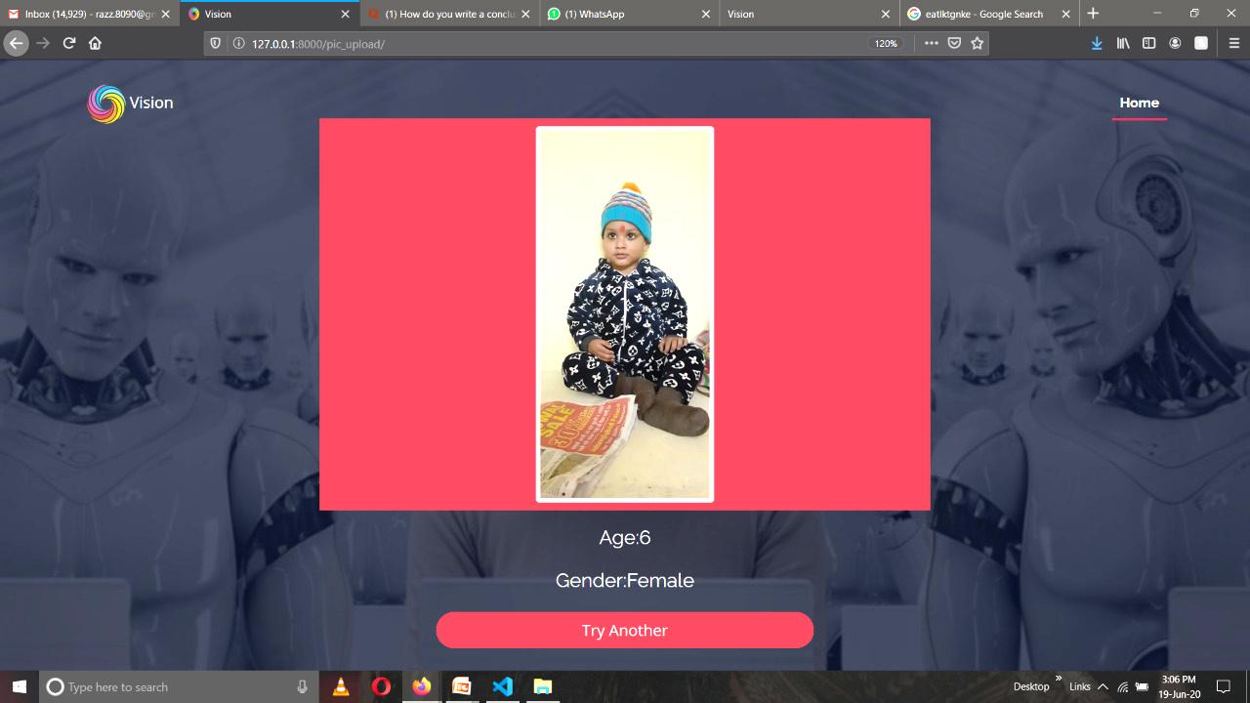

Figure 30: Page showing output of the prediction

### Subscription Form

{% load static %}

<!DOCTYPE html>

<html lang="en">

<head>

<meta charset="utf-8">

<title>Vision</title>

<meta content="width=device-width, initial-scale=1.0" name="viewport">

<meta content="" name="keywords">

<meta content="" name="description">

<!-- Favicons -->

<link href="{% static 'img/logo (2).png' %}" rel="icon">

<link href="{% static 'img/apple-touch-icon.png' %}" rel="apple-touch-icon">

< =================================== CDN ============================>

<!-- Google Fonts -->

<link href="https://fonts.googleapis.com/css?family=Open+Sans:300,300i,400,400i,700,700i|Raleway:300,400,500,700,800" rel="stylesheet">

<!-- Bootstrap CSS File -->

<link href="{% static 'lib/bootstrap/css/bootstrap.min.css' %}" rel="stylesheet">

<!-- Libraries CSS Files -->

<link href="{% static 'lib/font-awesome/css/font-awesome.min.css' %}" rel="stylesheet">

<link href="{% static 'lib/animate/animate.min.css' %}" rel="stylesheet">

<link href="{% static 'lib/venobox/venobox.css' %}" rel="stylesheet">

<link href="{% static 'lib/owlcarousel/assets/owl.carousel.min.css' %}" rel="stylesheet">

<!-- Main Stylesheet File -->

<link href="{% static 'css/style.css' %}" rel="stylesheet">

</head>

<body>

<!--========================== Header ============================-->

<header id="header">

<div class="container">

<div id="logo" class="pull-left text-light">

<!-- Uncomment below if you prefer to use a text logo -->

<!-- <h1><a href="#main">C<span>o</span>nf</a></h1>-->

<img src="{% static 'img/logo (2).png' %}" alt="" title="">Vision

</div>

<nav id="nav-menu-container">

<ul class="nav-menu">

<li class="menu-active"><a href="/">Home</a></li>

</ul>

</nav><!-- #nav-menu-container -->

</div>

</header>

< ================================ Form ===========================>

<section id="intro">

<div class="intro-container wow fadeIn">

<div class="container">

<div class="row my-5 ">

<div class="col-lg-6 mx-auto">

<div class="card mt-5 shadow">

<div class="card-body">

<h4 class="card-title text-center text-danger">Subscribe!</h4>

<form method="POST" action="submit/">

<div class="form-group">

<label for="">First Name</label>

<input type="text" class="form-control" name="name" id="" aria-describedby="emailHelpId"

placeholder="enter username"></div>

<label for="">Last Name</label>

<input type="text" class="form-control" name="last_name" id="" aria-describedby="emailHelpId"

placeholder="enter username">

<label for="">Email</label>

<input type="email" class="form-control" name="email" id="" aria-describedby="emailHelpId"

placeholder="enter username">

<button class="btn btn-danger btn-block" role="button">Subscribe</button>

</form>

</div>

</div>

</div>

</div>

</div>

</div>

</section>

< ============================== Script Files ======================== >

<script src="{% static 'lib/jquery/jquery.min.js' %}"></script>

<script src="{% static 'lib/jquery/jquery-migrate.min.js' %}"></script>

<script src="{% static 'lib/bootstrap/js/bootstrap.bundle.min.js' %}"></script>

<script src="{% static 'lib/easing/easing.min.js' %}"></script>

<script src="{% static 'lib/superfish/hoverIntent.js' %}"></script>

<script src="{% static 'lib/superfish/superfish.min.js' %}"></script>

<script src="{% static 'lib/wow/wow.min.js' %}"></script>

<script src="{% static 'lib/venobox/venobox.min.js' %}"></script>

<script src="{% static 'lib/owlcarousel/owl.carousel.min.js' %}"></script>

<script src="{% static 'js/main.js' %}"></script>

</body>

</html>

Figure 31: Subscription form for user

### Jumbotron

{% load static %}

<html>

<head>

<meta charset="UTF-8">

<meta name="viewport" content="width=device-width, initial-scale=1.0">

<meta http-equiv="X-UA-Compatible" content="ie=edge">

<title>Suscribe</title>

< ===================== CDN =====================>

<link rel="stylesheet" href="https://stackpath.bootstrapcdn.com/bootstrap/4.3.1/css/bootstrap.min.css"

integrity="sha384-ggOyR0iXCbMQv3Xipma34MD+dH/1fQ784/j6cY/iJTQUOhcWr7x9JvoRxT2MZw1T"crossorigin="anonymous">

<script src="https://code.jquery.com/jquery-3.3.1.slim.min.js"

integrity="sha384-q8i/X+965DzO0rT7abK41JStQIAqVgRVzpbzo5smXKp4YfRvH+8abtTE1Pi6jizo"crossorigin="anonymous"></script>

<script src="https://cdnjs.cloudflare.com/ajax/libs/popper.js/1.14.7/umd/popper.min.js"

integrity="sha384-UO2eT0CpHqdSJQ6hJty5KVphtPhzWj9WO1clHTMGa3JDZwrnQq4sF86dIHNDz0W1"crossorigin="anonymous"></script>

<script src="https://stackpath.bootstrapcdn.com/bootstrap/4.3.1/js/bootstrap.min.js"

integrity="sha384-JjSmVgyd0p3pXB1rRibZUAYoIIy6OrQ6VrjIEaFf/nJGzIxFDsf4x0xIM+B07jRM"crossorigin="anonymous"></script>

</head>

<body>

<div class="jumbotron text-center">

<h1 class="display-3">Thank You!</h1>

<p class="lead"><strong>Please check your email</strong> for further instructions on how to complete your account setup.</p>

<hr>

<p>

Having trouble? <a href="">Contact us</a>

</p>

<p class="lead">

<a class="btn btn-primary btn-sm" href="/" role="button">Continue to homepage</a>

</p>

</div>

</body>

</html>



Figure 32: Snapshot after subscription successful

# CONCLUSION

This paper introduced an approach to classify facial images into their corresponding gender and age. The main emphasis of this research is to apply the training and learning process of the human brain in pattern recognition and classification from the normal computer. Automatic classification of facial images into age and gender has been used in several applications in the commercial world such as video surveillance systems and enhance image searching in search engines. The proposed methodology used parameters taken from the geometric facial feature variations influenced by the two gender types and the facial skin texture variation in the ageing process. These parameters are then used to classify the images into corresponding gender and age by using a neural network. Facial images for our research are taken from the two databases namely FERET and FGNET which include the gender and age details along with each image.

We use facial images in the range of 8 – 63 as it is very difficult to recognize the gender of little babies by the geometric facial feature variations and also there are not enough facial images of people older than 64 to use in our experiment. For the effectiveness of identifying the age of a given facial image we have used four age groups namely 8 – 13, 14 – 25, 26 – 45 and 45 – 63 where each range has remarkable variations. We have used nearly 550 images for the training process including both male and female images within our interested age groups. Face detection and the facial parts such as eyes, nose and mouth area are located using the OpenCV Haar cascade classifiers. After that feature points required for the experiment are extracted using horizontal and vertical projections. There are many difficulties of correctly locating the feature points automatically in some cases when the face area contains birthmarks like patches and also due to different lighting conditions.

Parameters in the training data set is input to the neural network to train the system and it is used to classify a given query image into the corresponding gender and age group according to the learning done from the parameters used in the training process. There are two neural networks used for the classification of age and gender. Each of the neural networks performs accurately with one hidden layer comprising with suitable number of neurons.

According to the results taken from the proposed age and gender classification methodology, gender classification from facial images has significantly higher accuracy in classification training data as well as testing data. For the testing data the gender classifier results with a correct classification of 85.83% while the training data set gives 89.92% accuracy when using data from 40 images from each data set. This implies that the classification accuracy for the testing data set is very closer to the classification rate for the training dataset. This can be further interpreted that our proposed method for gender classification is a considerably accurate mechanism and it can be used as a successful mechanism in gender classification. According to the results taken from age classifier we can see that the accuracy for the training data set is 79.09% and 74.39% of accuracy for the testing data where we have used data from 40 images. Overall accuracy for the age and gender classifier is 70.5% which is a considerable high accuracy when compared to the overall classification accuracy by human brain which gives a 75% of accuracy. This shows that gender classification by human brain is 100% but when we come to age classification it is 75%, which shows the difficulty for the classification. Therefore we can conclude that the proposed age and gender classification methodology can be accepted as a successful mechanism.

Proposed methodology can be improved further to gain higher accuracy in classification. More parameters can be added to represent the geometric variation of gender to our classifier in order to increase the performance. Reducing the gap between age ranges would result with a better classification of images in to several age groups.

Identification of wrinkles is not 100% accurate as it depends on several external conditions such as facial make-up and smoothing done for the images. Therefore in future it is required to find out another set of parameters which do not cause these problems. Proposed algorithm can be enhanced to perform accurately under any condition of images in the future. Reducing the gap between the present age ranges would also be a reasonable suggestion to end up with a better classification.

# References

